CONCEPTUAL DESIGN REPORT FOR NAPHTHA SPLITTING UNIT

03 | 16 JUNE 2026 | R | IFA | A.A | R.A | N.F
02 | 9 JUNE 2026 | R | IFA | A.A | R.A | N.F
01 | 12 MAY 2026 | R | IFA | A.A | R.A | N.F
00 | 12 April 2026 | F | IFA | A.A | R.A | N.F
REV. | DATE | STAGE | POI | PREPARED | CHECKED | APPROVED
REVISION INDEX
SHEET NO. | REVISION |  |  |  |  | SHEET NO. | REVISION
SHEET NO. | 00 | 01 | 02 | 03 | 04 | SHEET NO. | 00 | 01 | 02 | 03 | 04
1
2
3
4
5
6
7
8
9
10
11
12
13
14
15
16
17
18
19
20
21
22
23
24
25
26
27
28
29
30
31
32
33
34
35
36
37
38
39
40
41
42
43
44
45
46
47
48
49
TABLE OF CONTENTS
1. PURPOSE 5
2. INTRODUCTION 5
3. DEFINITIONS 5
4. FEED RATE 5
5. FEED PROPERTIES 5
6. PRODUCT SPECIFICATIONS 6
7. TABRIZ REFINERY UTILITY CONDITIONS 7
7.1. STEAM 7
7.2. WATER 8
7.3. COOLING WATER 9
7.4. AIR 11
7.5. NITROGEN 12
7.6. ELECTRICAL POWER 12
7.7. FUEL 13
7.8. FUEL SPECIFICATION 14
8. TABRIZ CLIMATE & SITE CONDITION 15
9. DESCRIPTION OF DIFFERENT CASES 16
9.1. PROCESS CHEMISTRY 16
9.2. FEED DATA CHARACTERISTICS 17
9.3. GENERAL 25
9.4. TECHNICAL FEASIBILITY 26
9.5. PROJECT SPECIFICATION 26
10. PROJECT SCENARIO 27
10.1. SCENARIO-1: TWO TOWERS (TV-191 & TV-192) IS WORKING WITH TOGETHER 27
10.1.1 SC-1:CASE-1 : TWO TOWERS (TV-191 & TV-192) ALL IN SERVICE 27
10.1.2 SC-1 : CASE-2 : IN RANGE FEED 40
10.2. SCENARIO 2: USING ONLY ONE TOWER WITH SIDE DRAW 44
11 CONCLUSION 46
- PURPOSE
A naphtha splitter unit consists of distillation columns to separate feed into light naphtha, heavy naphtha and heavy cuts. This separation is crucial for preparing feedstocks for downstream units like catalytic reformers and isomerization units, which further process these cuts to produce gasoline and other high-value products.
- INTRODUCTION
TABRIZ OIL REFINING COMPANY (here after referred to as TZORC or OWNER) intends to install Naphtha Splitting unit. “Tabriz Oil Refining Company (TZORC)”, a subsidiary of “Parsian Oil and Gas Development Company (POGDC)”, owns and operates 110,000 BPSD Tabriz Oil Refinery located in Tabriz, Iran. The basic designer of Tabriz Oil Refinery was UOP with the capacity of 80,000 BPSD while the detailed design and construction executed by Snamprogetti Company in 1975-1977. In 1993, the refinery capacity was increased to 110,000 BPSD. TZORC intends to build a new Naphtha Splitting unit (unit No. 190) with a capacity of 6,000 BPSD of whole Naphtha. The objective of the Naphtha Splitting unit is to split feedstock into Light Naphtha, Heavy Naphtha and Heavy Cut.
- DEFINITIONS
PROJECT TITLE | TABRIZ REFINERY NAPHTHA SPLITTING PROJECT
OWNER | TABRIZ OIL REFINING COMPANY
CONSULTANT | Hormozan Energy Industry Development Company (HEIDCO)
LICENSOR
CONTRACT | The contract between OWNER and CONSULTANT for the execution of the PROJECT
CONTRACT No. | 1404-100

- FEED RATE
The unit has a design charge of 6’000 BPSD.

- FEED PROPERTIES
The composition and conditions of the feed are as follows:

Table 1 : Feed Properties ASTM-D86
Test Unit | Results
Sp. Gr 60/60 °F | 0.7266
Liquid Vol. Percent (%) | Temperature (°C)
IBP | 38.8
5 % | 50.3
10 % | 58.1
15 % | 64.5
20 % | 70.9
30 % | 83.4
40 % | 97.4
50 % | 111.2
60 % | 125.4
70 % | 142.3
80 % | 164.8
85 % | 179.9
90 % | 201
95 % | 229.9
FBP | 284.4
RVP (kPa) | 63.24
R-SH (ppm) | 1200
T.S (ppm) | 3400
Water Content Wt.% | 0.03
- PRODUCT SPECIFICATIONS
The specifications of the products will be as bellow:

Light Naphtha
Table 2 : Light Naphtha Data Specification
Density @ 15.6 °C | ASTM D-1298 | 0.6500 - 0.6800
Distillation | ASTM D-86 | 30 °C - 105 °C
Color | ASTM D-156 | (Min) 25
R.V.P | ASTM D-323 | (Max) 90 Kpa

Heavy Naphtha
Table 3 : Heavy Naphtha Data Specification
Density @ 15 °C | ASTM D-1298 | 0.7300 - 0.7500
Distillation | ASTM D-86 | 85 °C - 180 °C
Color | ASTM D-156 | (Min) 25

- TABRIZ REFINERY UTILITY CONDITIONS
- STEAM
Unit battery limits operating and equipment mechanical design conditions are as detailed in the below Table:

Table 4: Steam Unit Battery Limit Operating And Equipment Mechanical Design Conditions
 |  | PROCESS and UTILITY LIMIT CONDITIONS |  |  |  | EQUIPMENT MECHANICAL DESIGN CONDITIONS
IDENTIFICATION |  | PRODUCER BATTERY |  | CONSUMER BATTERY |  | PIPING |  | VESSELS AND |  | TURBINES
 |  | LIMIT |  | LIMIT |  |  |  | EXCHANGERS
 |  | bar (ga) | °C | bar (ga) | °C | bar (ga)(1) | °C | bar (ga) | °C | bar (ga) | °C
TURBINE
GENERATOR
 | UTILITY | …. (MIN) | …. (MIN) | …. (MIN) | …. (MIN)
 | AREA | …. (MAX) | …. (MAX) | …. (MAX) | …. (MAX)
HPS
 | PROCESS | 43 (MIN) | 350 (MIN) | 38 (MIN) | 330 (MIN) | 55 | 395 | 55 | 395 | 55 | 395
 | AREA | 50 (MAX) | 395 (MAX) | 40 (MAX) | 395 (MAX)
 |  |  |  | 39 (NOR) | 350 (NOR)
MPS | (3) | 11.5 (MIN) | 200 (MIN) | 9.6 (MIN) | 183 (MIN) | 15 | 350 | 15 | 350 | 15 | 350
 |  | 12.8 (MAX) | 270 (MAX) | 11 (MAX) | 220 (MAX)
 |  |  |  | 10.7 (NOR) | 200 (NOR)
LPS | (3) , | 4.0 (MIN) | 170 (MIN) | 3.2 (MIN) | 145 (MIN) | 5.7 | 232 | 5.7 | 232 | 5.7 | 232
 |  | 5.0 (MAX) | 200 (MAX) | 4.0 (MAX) | 180 (MAX)
 |  |  |  | 3.5 (NOR) | 150 (NOR)
Local Network at Utility | (2) |  |  |  |  | 3.5 | 150 | 3.5 | 170 | 3.5 | 150
NOTES:
1) System safety valve set pressure.
2) Local Network at Utility is low pressure recovered steam from condensate flash drums and shall be condensed by means of air cooler(s). Location of air cooler(s) will be determined based on the economical point of view.
3) Operating temperature for reboilers process design shall be: MPS: HP
- WATER
Unit battery limit operating and equipment mechanical design Conditions are as detailed in the below Table:

Table 5: Water Unit Battery Limit Operating and Equipment Mechanical Design Conditions
 |  | PROCESS / UTILITY BATTERY LIMIT |  |  |  | EQUIPMENT MECHANICAL DESIGN
SYSTEM |  | CONDITIONS |  |  |  |  |  | CONDITIONS
IDENTIFICATION |  | PRODUCER BATTERY |  | CONSUMER BATTERY |  | PIPING |  | VESSELS AND |  | TURBINES
 |  | LIMIT |  | LIMIT |  |  |  | EXCHANGERS
 |  | BARG | °C | BARG | °C | BARG | °C | BARG | °C | BARG | °C
HP BOILER
FEED WATER |  | 56 | 118 | 55 | 75 - 115 | 61.6 | 129.8 | 61.6 | 129.8 | 61.6 | 129.8
MP BOILER
FEED WATER
COOLING
WATER SUPPLY |  | 4 | 29.5 | 2.8 | 29.5 | 5.2 | 121
COOLING
WATER RETURN |  | 2 | 46 | 1.75 | 46 | 5.2 | 121
RAW WATER |  | 5.45 | 25 | 4.5 (MIN) | 25 | 6.9 | 85
PLANT WATER |  | 5.45 | 25 | 4.5 (MIN) | 25 | 6.9 | 85
DRINKING WATER |  | 5.3 | 25 | 4.5 (MIN) | 25 | 6.9 | 85
FIRE WATER |  | 10.7 | 25 | 10.0 (MIN) | 25 | 12.7 | 85
DEMINERALIZEED
WATER
DESALINATED
WATER
Notes :
1) At most remote hydrant.
2) Allowable pressure drop shall be less than …. bar , for cooler , condenser and machine cooling equipment.
3) Cooling tower is designed based on cooling water return temperature of 45 °C .

- COOLING WATER
specification is described in the below table:

Table 6 : Cooling Water Specification
DESCRIPTION | CIRCULATING COOLING  WATER | COOLING TOWER  MAKE-UP | RAW  WATER | BFW
SERVICE
PH | 7.9 - 8.4 | 8.3 - 8.9 | 7.3 | 10.5 - 11
TOTAL HARDNESS AS CaCO3 (mg/kg) | 800-1000 | 130 - 300 | 130 - 300 | < 1 ppm
CALCIUM AS CaCO3 (mg/kg) | 800-900 | 100 - 200 | 100 - 200 | < 1
MAGNESIUM AS CaCO3 (mg/kg) | 100 -200 | 30 - 100 | 30 - 100 | < 1
TOTAL ALKALINITY AS CaCO3 (mg/kg) | 50 - 170 | 70 - 85 |  | < 100
SODIUM (mg/kg)
POTASSIUM (mg/kg)
SULFATE (mg/kg)
CHLORIDE (mg/kg) | 1000-1200
NITRATE (mg/kg)
SILICA AS SiO2 | 50-100 | 100 | 100 | =< 2 ppm
TOTAL IRON (mg/kg) |  |  |  | NIL
SUSPENDED SOLIDS (mg/kg)
DISSOLVED SOLIDS (mg/kg) | 1500-2000 | 400 - 1000 | 350 - 1400 | < 100ppm
COD (mg/kg)
OTHERS

Notes :
1) At most remote hydrant.
2) Allowable pressure drop shall be less than …. bar , for cooler , condenser and machine cooling equipment.
3) Cooling tower is designed based on cooling water return temperature of 45 °C .

Table 7 : Condensate Unit Battery Limit Operating and Equipment Mechanical Design Conditions
 | PROCESS / UTILITY |  |  |  | EQUIPMENT MECHANICAL DESIGN CONDITIONS
 | BATTERY LIMIT
SYSTEM | CONDITIONS
IDENTIFICATION | PRODUCER |  | CONSUMER |  | PIPING |  | VESSELS |  | TURBINES
 | BATTERY |  | BATTERY |  |  |  | &
 | LIMIT |  | LIMIT |  |  |  | EXCHANGERS
 | BARG | °C | BARG | °C | BARG | °C | BARG | °C | BARG | °C
HP HOT
CONDENSATE | 9.5 | 180 | 9.0 | 175 | 12.8 | 232 | 12.8 | 232 | 12.8 | 232
LP HOT
CONDENSATE | 2.5 | 135 | 2.1 | 130 | 5.7 | 170 | 5.7 | 170 | 5.7 | 170
COLD
CONDENSATE | 7.1 | 51 | 6.0 | 50 | 8.6 | 85 | 8.6 | 85 | 8.6 | 85
PUMP FLASHED
CONDENSATE
Note:
The Hp condensate shall be free of oil, otherwise the HP hot condensate shall be routed to LP hot condensate network.

- AIR
Unit battery limit operating and equipment mechanical design Conditions are as detailed in the below Table:

Table 8 : Air Unit Battery Limit Operating & Equipment Mechanical Design Condition
 | PROCESS / UTILITY |  |  |  | EQUIPMENT MECHANICAL
 | BATTERY LIMIT |  |  |  | DESIGN
SYSTEM | CONDITIONS |  |  |  | CONDITIONS
IDENTIFICATION | PRODUCER  BATTERY  LIMIT |  | CONSUMER  BATTERY  LIMIT |  | PIPING |  | VESSELS  &  EXCHANGERS
 | BARG | °C | BARG | °C | BARG | °C | BARG | °C
PLANT AIR | 7 | 35 | 5.3 | 35 | 8.5 | 85 | 8.5 | 85
INSTRUMENT AIR | 7 | 35 | 3 | 32 | 8.5 | 85 | 8.5 | 85
REGENERATION AIR

Table 9 : Air System Specifications
 | SERVICE
DESCRIPTION | PLANT AIR | INSTRUMENT AIR
DRIVER TYPE OF COMPRESSORS | ELECTRIC MOTOR / STEAM TURBINE
FURNISHED DRY AIR DEW POINT | - | -40 °C
WILL SYSTEM FURNISH OIL FREE AIR | OIL FREE | DRIED AND OIL FREE
TOTAL NO./CAPACITY OF COMPRESSORS | by Consultant | by Consultant
Note 1:
Power Supply for DCS& ESD 110VACby UPS (full redundant)
Field instrument: 24 VDC

- NITROGEN

Unit battery limit operating and equipment mechanical design Conditions are as detailed in the below Table:

:
Table 10 : Nitrogen Design Condition
System Identification | Process / Utility battery limit Conditions |  |  |  | Mechanical Design Conditions
System Identification | Producer Battery Limit |  | Consumer Battery Limit |  | Piping
System Identification | Bar g | °C | Bar g | °C | Bar g | °C
Gaseous Nitrogen | 4 | 10 | 2-3 | 10 | 8.0 | 50

- ELECTRICAL POWER

Table 11 : Electrical System Voltage Levels
SYSTEM | VOLTAGE (VOLT)
GENERATION | 6300
POWER RECEIVING FROM NATIONAL GRID | 20000
DISTRIBUTION | 6300
POWER (MEDIUM VOLTAGE) | 6300
POWER (LOW VOLTAGE) | 400/230
LIGHTING | 400/230
INSTRUMENTATION | 110 AC
INSTRUMENTATION (SHUT DOWN)(Note1) | 110 DC
CONTROL POWER FOR LV SWITCHGEAR OUTGOINGS | 230AC
CONTROL POWER FOR LV SWITCHGEAR INCOMINGS and BUSTIE | 110 DC
CONTROL POWER FOR MV/HV SWITCHGEAR INCOMINGS, BUSTIE and OUTGOINGS | 110 DC

Table 12 : Voltages To The Motors
MOTOR SIZE | VOLTAGE | PHASE
LESS THAN 0.4 KW | 400/230 | 3/1
0.4 KW AND UP TO 149 KW | 400/230 | 3
150 KW AND ABOVE | 6000 | 3

Note 1:
Power Supply for DCS& ESD 110VACby UPS (full redundant)
03
Field instrument: 24 VDC

- FUEL
Unit battery limit operating and equipment mechanical design Conditions are as detailed in the below Table:

Table 13 : Fuel Unit Battery Limit Operating And Equipment Mechanical Design Conditions
 | PROCESS / UTILITY BATTERY LIMIT |  |  |  | EQUPMENT MECHANICAL DESIGN
 |  | CONDITIONS |  |  | CONDITIONS
SYSTEM | PRODUCER |  | CONSUMER |  |  |  | VESSELS
IDENTIFICATION | BATTERY |  | BATTERY |  | PIPING |  | &
 | LIMIT |  | LIMIT |  |  |  | EXCHANGERS
 | BARG | °C | BARG | °C | BARG | °C | BARG | °C
FUEL OIL SUPPLY | 10.3 | 121 | 9 | 121 | 12.5 | 215 | 12.5 | 215
FUEL OIL RETURN | 8.5 | 121 | 8 | 121 | 12.5 | 215 | 12.5 | 215
FUEL GAS | 4.2 | 49 | 3.4 | 49 | 4.8 | 85 | 4.8 | 85
NATURAL GAS
NAPHTHA
Note :
The fuel system shall be designed in accordance with the requirements stipulated in " IPS-E-PR-340 " , " PROCESS DESIGN OF FUEL SYSTEM ".
- FUEL SPECIFICATION

Table 14: fuel specification

 | TYPE
DESCRIPTION | OIL |  | GAS
DESCRIPTION | FUEL OIL | START-UP  OIL | FUEL GAS  min. LHV | FUEL GAS  max. LHV | NATURAL  GAS
API GRAVITY | 9
RELATIVE DENSITY AT 15.6 °C |  |  | 0.64 | 1.34
VISCOSITY AT 100 °C (Pa.s)
VISCOSITY AT THE BURNER (SSU) | 200
TEMPERATURE AT THE BURNER (°C) | 113 |  | 38 | 38
LOWER HEATING VALUE FOR LIQUID
FUELS (kJ/kg) (LHV) | 40,000
LOWER HEATING VALUE FOR GAS (BTU/SCF) |  |  | 1050 | 2200
AVAILABILITY OVER USE (m3/h) (GPM)
VANADIUM / NICKEL mg/kg) (PPM) | 75
SODIUM (mg/kg)
SULFUR (mg/kg) ( wt. %) | 3.7 |  |  | 5 grain / 100CF
ASH CONTENT (mg/kg)
FLASH POINT (°C)
H2S (mg/kg)
HEADER PRESSURE , NORMAL (barg) | 10 |  | 3.9
HEADER TEMPERATURE (°C) | 120
Note:
Furnace design with fuel oil is not allowed.

- TABRIZ CLIMATE & SITE CONDITION
The project site conditions are described in the below Table:

Table 15 : Site Condition Data
REQUIREMENTS | UNITS | DESCRIPTION
Location:  - Exact Site location  - Elevation above sea level  - Plant datum level  - Soil bearing capacity (note 1) | M  Kg/cm² | 1362  2.0 (to be verified)
Earthquake:  - Earthquake  - Seismic intensity (Mercalli scale) |  | Yes  UBC ZONE-4
Barometric pressure:  - Highest absolute barometric pressure  - Lowest absolute barometric pressure  - Annual average barometric pressure (process design) | Kg/cm²  Kg/cm²  Kg/cm² | 0.896  0.863  0.8824
Temperature:  - Average maximum temperature (hottest month)  - Extreme highest temperature  - Average minimum temperature (coldest month)  - Extreme lowest temperature  - Average ambient temperature (process design)  - Design air temperature for Air-coolers  - Design air temperature for Stacks  - Design wet bulb temperature (cooling towers)  - Minimum temperature (metallurgical design)  - Winterizing temperature | °C  °C  °C  °C  °C  °C  °C | 41.5  -25  12  36  24  -25  -25
Relative humidity:  - Average relative humidity in warmest mouth  - Average relative humidity in coldest mouth  - Design relative humidity in Summer  - Design relative humidity in Winter  - Average relative humidity of the year | %  %  % | 69.6  100  53.7
Rainfall:  - Maximum daily rainfall  - Maximum hourly rainfall  - Average yearly rainfall  - Yearly maximum rainfall | mm  mm  mm  mm | 80  50  308  400
Wind direction:  - Prevailing wind direction whole year  - Prevailing wind direction Summer  - Prevailing wind direction Winter |  | East to West
Wind velocity:  - Average wind velocity (process design)  - Wind Velocity in Summer  - Wind Velocity in Winter  - Design wind speed for structure | m/s  m/s  m/s | 13.5  19.3  44.4
Snowfall:  - Maximum snowfall depth  - Design snow load | cm  KN/m² | 45  1.5
Thunder and lightning:  - Annual average number of days  - Maximum days of thunder and lightning in the year  - Electrical current from thunder/lightning  - Soil resistance | day  day  kA  Ohm/cm | 33.4  49
2 INFORMATION FOR INSULATION DESIGN  - Mechanical design minimum ambient temperature for non-insulated equipment/piping  - Design maximum temperature for personnel protection  - Design minimum ambient temperature for insulation/ tracing  - Maximum allowable furnace skin temperature  at ambient temperature of 24 °C  - Wind velocity | °C  °C  °C  °C  m/s | -25  60  -25  60  10
Miscellaneous Information  - Airborne material (process/mechanical design)  - Frost line (below surface)  - Water Table (minimum depth) (note 1)  - Water Table (maximum depth) (note 1) | m  m  m | Salt / Sand  1 m below grade level  8.0  10

This report is main report, which is part of engineering study of conceptual design for naphtha splitting unit (NSU) as per below.
- DESCRIPTION OF DIFFERENT CASES
- PROCESS CHEMISTRY

Naphtha, like other petroleum fractions, contains varying amounts of naturally occurring contaminants including organic sulfur, nitrogen, and may be some metal compounds. These contaminants are removed by hydrotreating process which is a proprietary, fixed bed, catalytic hydrogenation method to upgrade the quality of light and heavy naphtha with a negligible effect on the boiling range .Hydrotreating is designed primarily to remove sulfur and nitrogen.
In petroleum refining, Naphtha is a critical intermediate product derived from crude oil distillation, catalytic cracking, or other conversion processes. It typically separated into light Naphtha and heavy Naphtha to optimize their use in gasoline blending, reforming, or as feedstock for petrochemical units.
A Naphtha splitter (also called a naphtha fractionator) is a distillation column designed to separate full-range Naphtha into:

Light Naphtha (LN):
Typically C5–C6 or C5–C7 hydrocarbons, used for gasoline blending or as isomerization feedstock.
Heavy Naphtha (HN):
Typically C7–C10 or C7–C11 hydrocarbons, used as reformer feedstock to produce high-octane gasoline or aromatics.

Heavy Cut (optional):
A heavier fraction (e.g., C11+) that may be directed to diesel blending or other downstream units.
The Light Naphtha-Heavy Naphtha and Heavy Cut Splitter is thus a key unit for optimizing refinery margins, improving product quality, and enabling downstream process efficiency.

- FEED DATA CHARACTERISTICS
Crude oil assay data is a comprehensive set of specifications that details the physical and chemical characteristics of a specific crude oil. The specifications are typically grouped into three main categories: the overall properties of the crude, its elemental composition, and a detailed breakdown of its fractions.

Table 16 : Feed Data Characteristics
03
Category | Specifications | Typical Values / Interpretation
Overall Properties | API Gravity | Measures how heavy or light the oil is. As per client data Sp. Gr 60/60 °F = 0.7266
Overall Properties | Sulfur Content | Classifies oil as Sweet (< 0.5 wt.%) or Sour (> 0.5 wt.%). Lower sulfur content is more desirable and requires less refining. As per client data total sulfur = 3400 ppm
Overall Properties | Viscosity | Resistance to flow. Influences transportation and refining.
Overall Properties | Pour Point | The lowest temperature at which the oil will flow. Important for handling and pipeline transport.
Overall Properties | Reid Vapor Pressure (RVP) | A measure of volatility. Important for safety in storage and transport.
Compositional Analysis | Carbon, Hydrogen, Nitrogen | Carbon (typically 83-87% wt.), Hydrogen (typically 11-14% wt.). Nitrogen is an impurity.
Compositional Analysis | SARA Analysis | Separates crude into Saturates, Aromatics, Resins, and Asphaltenes. Determines crude oil type and processing strategy.
Compositional Analysis | Metal Content (Ni, V, Fe) | Metals can poison refinery catalysts. Values are often in the parts per million (ppm) range (e.g., Ni ≤ 1 ppm). NO Data Available in This Project
Distillation Profile (Yield) | Light Ends (Methane to Nonane) | Determines the yield of valuable products like naphtha and gasoline.
Distillation Profile (Yield) | Cut Point Intervals | Volume or weight percentage of crude that boils within specific temperature ranges. Defines potential yields of naphtha, kerosene, diesel, gas oil, and residue.
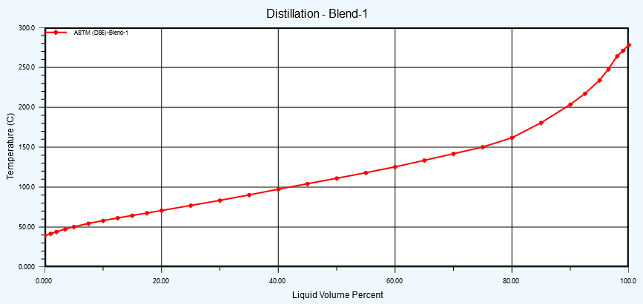
Figure 1: Assay Data Characteristic as per ASTM D86

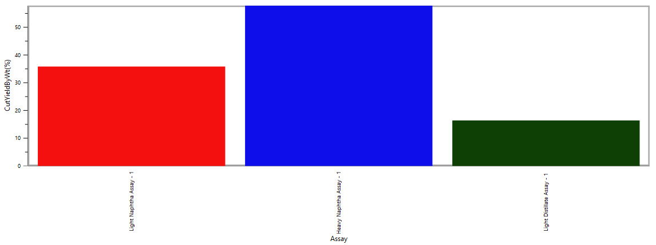
03
Figure 2 : Cut Yields(wt.%) Petroleum Assay Graph

Table 17 : Petroleum Assay Result Summary
Whole Crude |  | Cut1 | Cut2 | Cut3 | Cut4 | Cut5 | Cut6 | Cut7 | Cut8 | Cut9 | Cut10 | Cut11 | Cut12 | Cut13 | Cut14 | Cut15 | Cut16
Initial Temperature: (C) | IBP | IBP | 38.8 | 50.3 | 58.1 | 64.5 | 70.9 | 83.4 | 97.4 | 111.2 | 125.4 | 142.3 | 164.8 | 179.9 | 201 | 229.9 | 284.4
Final Temperature: (C) | FBP | 38.8 | 50.3 | 58.1 | 64.5 | 70.9 | 83.4 | 97.4 | 111.2 | 125.4 | 142.3 | 164.8 | 179.9 | 201 | 229.9 | 284.4 | FBP
Std Liq.Density (kg/m3) | 726.69 | 593.8 | 708.5 | 699.4 | 699.9 | 701.3 | 711.8 | 722.7 | 733.6 | 744.5 | 754.39 | 766.53 | 776.58 | 786 | 797.82 | 807.04 | 825.31
Cut Yield By Vol (%) | 100 | 12.859 | 5.3568 | 4.0287 | 3.5496 | 3.6332 | 6.8019 | 7.3973 | 7.3133 | 7.8662 | 9.0597 | 10.8409 | 6.0256 | 6.0237 | 4.5188 | 4.7249 | 0.0003
Sulfur By Wt. (ppm) | 3400 | 0.003 | 3.143 | 7.232 | 15.812 | 26.536 | 87.690 | 193.105 | 448.355 | 842.027 | 1533.740 | 3033.264 | 5119.125 | 8272.83 | 14774.20 | 22566.8 | 51618.51
Mercaptan By Wt. (ppm) | 1200 | 0 | 0.000 | 0.000 | 0.006 | 0.015 | 0.069 | 0.503 | 2.420 | 9.890 | 36.112 | 168.315 | 473.159 | 1499.42 | 5354.24 | 14906.72 | 99345.17

Table 18 : Petroleum Assay Result INFO
03
ASSAY RESULT INFO
General Information | Pure Components (% wt.) |  |  | Whole Crude Properties |  |  | TBP Distillation
NAME: TABRIZ PETROLEUM ASSAY | Methane | 0 |  | SP.GR @60/60 |  | 0.7266 | C |  |  | wt.% |  | vol%
Region | Ethane | 0 |  | Sulfur By Wt. (%) |  | 0.34 | 39 |  |  | 8.462 |  | 10.06
Country | Propane | 0 |  | Kinematic Viscosity (Cst)@ 50 (C) |  | 0.603 | 85 |  |  | 33.33 |  | 36.24
Sample Date | Isobutane | 0 |  | Kinematic Viscosity (Cst)@ 100 (C) |  | 0.43 | 105 |  |  | 43.58 |  | 46.56
Source Reference | N-Butane | 0 |  | Kinematic Viscosity (Cst)@ 150 (C) |  | 0.327 | 180 |  |  | 81.2 |  | 82.87
Characterized By | Isopentane | 0 |  | Nitrogen By Wt. (%) |  | -- | 185 |  |  | 97.42 |  | 97.75
 | N-Pentane | 0 |  | Vanadium By Wt. (%) |  | 0 | 284 |  |  | 8.462 |  | 10.06
 | Benzene | 0 |  | Nickel By Wt. (%) |  | 0
 | Cyclopentane | 0 |  | Asphaltene By Wt. (%) |  | 0
 | C6-NAPHTHENES | 0 |  | Conradson Carbon By Wt. (%) |  | 0
 | C6-PARAFFINS | 0 |  | Watson K |  | 12.12
 | C7-NAPHTHENES | 0 |  | Wax Content (%) |  | 2.935
 | C7-PARAFFINS | 0 |  | Total Acid Number (mg KOH/g) |  | 0.047
 | Toluene | 0 |  | Pour Point (C) |  | -110
Cut Data | Crude | LN | HN | HC
Start ( C ) | IBP | 30 | 85 | 180
End ( C ) | FBP | 105 | 180 | 284
Cut Yield By Vol (%) | 100 | 37.1 | 46.63 | 16.270
Cut Yield By Wt. (%) | 100 | 35.68 | 47.88 | 16.44
Watson K | 12.12 | 12.16 | 12.02 | 12.08
Total Sulfur By Wt. (%) | 0.34 | 0.008 | 0.1167 | 0.2153
Total Mercaptan Sulfur By Wt. (%) | 0.12 | 1E-05 | 0.00169 | 0.1183
Basic Nitrogen By Wt. (%) | - | - | - | -
Total Acid Number (mg KOH/g) | 0.048 | 0.028 | 0.0473 | 0.0922
Kinematic Viscosity (CST)@ 50 (C) | 0.603 | 0.396 | 0.6031 | 1.3181
Kinematic Viscosity (CST)@ 100 (C) | 0.43 | 0.296 | 0.4103 | 0.7508
Kinematic Viscosity (CST)@ 150 (C) | 0.327 | 0.228 | 0.3136 | 0.4924
Paraffins By Wt. (%) | 54.26 | 54.52 | 51.142 | 44.196
Naphthene By Wt (%) | 45.29 | 45.48 | 48.46 | 54.196
Arom By Wt. (%) | 0.46 | 0 | 0.3971 | 1.6082
RON Clear | 50.57 | 59.65 | 42.851 | 30.461
MON Clear | -- | 58.05 | 43.146 | --
RVP (psia) | 9.172 | 5.48 | 1.1098 | 0.6759
ASSAY RESULT INFO (Cut Data)
FLUID SPECIFICATION |  | LN | HN | HC
Start ( C ) | IBP | 30 | 85 | 180
End ( C ) | FBP | 105 | 180 | 284.4
Naphthalene’s By Wt. (%) | 0 | 0 | 0 | 0
Smoke Pt (mm) | 36.92 | 42.76 | 32.966 | 25.337
Freeze Point (C) | -29.3 | -117 | -73.74 | -21.19
Cloud Point (C) | -39.7 | -107 | -76.74 | -29.24
Pour Point (C) | -110 | -133 | -99.07 | -57.34
Cetane Index - ASTM-D4737 | 39.55 | 32.04 | 38.683 | 52.252
Wax Content (%) | 2.935 | 1.529 | 2.8452 | 5.9316
Conradson Carbon By Wt. (%) | 0.003 | 0 | 0 | 0
Asphaltene By Wt. (%) | 0 | 0 | 0 | 0
03

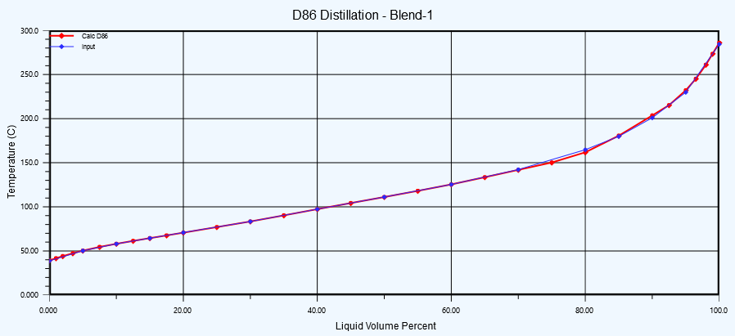  Figure 3 : Assay Data Matching | Heavy Cut  Heavy Naphtha  Light  Naphtha  Figure 4 : Cut Point Info Graph
03
as per above feed characteristic is it possible to derivative below cut points for above mentioned data:

  Product | Boiling Range
  Light Naphtha | 30–105 °C
  Heavy Naphtha | 85–180°C
  Product | Boiling Range
  Heavy cut | 180+ °C

Note :
- Sulfur-containing molecules are generally heavier than paraffins of similar carbon number. During distillation Light sulfur compounds may leave with light naphtha. Most sulfur compounds concentrate in heavier naphtha fractions. Solid sulfur and Aromatic sulfur compounds accumulate in heavy naphtha and heavy cut.
- The sulfur wt.% increases from Light Naphtha to Heavy Naphtha & Heavy Cut because solid sulfur & sulfur mercaptan is containing compounds have higher boiling points than most paraffinic hydrocarbons. During crude fractionation and naphtha splitting, these sulfur compounds concentrate in the heavier boiling fractions, resulting in progressively higher sulfur concentrations in Heavy Naphtha and Heavy Cut streams.

In Aspen HYSYS software, the Assay Result Info Report is a summary generated after characterized a petroleum fluid (crude oil or condensate) using the Assay Management tool.
When you include Distillation Cut Specifications (such as ASTM D86, D1160, D2892, or TBP curves) in assay, HYSYS data points will be build a comprehensive mathematical model of the fluid’s composition.

It allows to see how closely the HYSYS simulation matches the laboratory data is provided. It typically contains:
- Blending/Characterization Summary:
A breakdown of the calculated properties (API gravity, molecular weight, viscosity, sulfur content, etc.) for the whole fluid.
- Cut Point Data:
A comparison between input distillation laboratory data and the HYSYS-calculated distillation curve.
- Property Curves:
Plots of how properties (like density or viscosity) change as “cut” the oil at different boiling temperatures.

The report provides the following insights based on these specs:
- Deviation Analysis: It calculates the difference between experimental laboratory distillation data points and the HYSYS input curve. If the deviation is high, need to adjust characterization method (e.g., changing the property correlation or the number of pseudo-components).
- Pseudo-component Breakdown: HYSYS breaks the crude into a series of “pseudo-components” (hypothetical components defined by boiling point ranges). The report shows you how these components align with your distillation cuts.
- Yield Predictions: By defining these cuts, the software can accurately predict the yield of various fractions (e.g., Naphtha, Kerosene, Diesel, Gas Oil) when eventually connect this stream to a Distillation Column simulation.
- Based on feed characterization study the large portion is Heavy Naphtha, which is the biggest fraction.
- Based on feed characterization study the Light Naphtha Cut is moderate portion Fraction
- Based on feed characterization study the final portion is Heavy cut that is heaviest cut point in feed and distillated in first tower (TV-191).
- “The generation of an ‘off-gas’ fraction is attributed to the presence of components with extremely low boiling points relative to the defined Light Naphtha specification (IBP of 30°C). Although the cut point data coverage is shown relatively small off-gas yield, a discrepancy exists between the client-provided ASTM D86 distillation data and the initial boiling point (IBP). While the provided data suggests the presence of light-end compositions in the 30°C to 38.8°C range, the HYSYS feed characterization, based on an IBP of 38.8°C, indicates no significant light-end content. Consequently, to ensure a realistic simulation, the off-gas fraction has been excluded, and a total condenser configuration has been selected for the column.”

- GENERAL

A Naphtha splitter is a fractional distillation column used in refineries and petrochemical plants to separate Naphtha into two main products(light Naphtha and heavy Naphtha) based on differences in boiling point ranges.
The unit splits full-range Naphtha (typically from crude distillation or other processes) into two key fractions:
- Light Naphtha (LN) – Lower boiling point components
- Heavy Naphtha (HN) – Higher boiling point components
Typical Boiling Point Ranges are as below:

Table 19 : Feed Boiling Range (Typical)
Fraction | Typical Boiling Range | Key Components
Light Naphtha | 30–105 °C  (86–221°F) | C5–C6 hydrocarbons  (Pentanes, Hexanes)
Heavy Naphtha | 85–180°C  (185–356°F) | C7–C12hydrocarbons  (Paraffinic, Naphthene’s)
Heavy Cuts | More Than 180 °C
03
Generally ,The function of this unit in the new project is to fractionate the Whole Naphtha into three streams, namely Light Naphtha, Heavy Naphtha and Heavy Cut. Light Naphtha will be routed to the Isomerization Unit feedstock storage tanks, while Heavy Naphtha will be routed to the CCR Unit feedstock storage tanks, and Heavy Cut will be routed to the gasoil pool / to the GHP unit.
For Tabriz refinery project , A Naphtha splitter unit consists of distillation columns to separate feed into light Naphtha, heavy Naphtha and heavy cuts. This separation is crucial for preparing feedstocks for downstream units like catalytic reformers and isomerization units, which further process these cuts to produce gasoline and other high-value products. For this project is requested to specify the number of required columns and design the unit for using the splitting Light and heavy Naphtha cuts in existing Isomeration and gasoline production units, respectively.
Unit with two columns (Pre-fractionator and Splitter) is preferred. The design will be performed in two cases, in the first case two columns will be served in series when the feed is out of range to separate heavy cut in the first column and Light and Heavy Naphtha products in the second column. While in the second case only second column (Splitter) will be involved when the feed is in the desired range.

- TECHNICAL FEASIBILITY

Process Design:

The splitter is typically packed or multi-tray distillation column with a reboiler and overhead condenser. The design depends on the feed composition, desired cut points, and product specifications.
Operating Conditions: Light Naphtha is taken overhead, heavy Naphtha as a side draw or bottom product, and heavy cut as bottoms’ product.

Operating pressure:
Hysys or Petrosim software will show the operating data in column and related column profile which is optimized to balance temperature and energy use.

Materials of Construction:
Carbon steel is generally sufficient, though corrosion considerations may require upgrades depending on sulfur content. Internal of column will be considered stainless steel

- PROJECT SPECIFICATION

- Unit: Naphtha Splitting Unit (Unit-190)
- Capacity: 6,000 BPD of feed naphtha
- Feed: Naphtha blend (TBP: 38.8 °C (IBP) to 284.4°C (FBP))
- Products:
  - Light Naphtha (30–105°C, density 0.650–0.680)
  - Heavy Naphtha (85–180°C, density 0.730–0.750)
  - Heavy Cut (remainder)
- Objective: Split feed for downstream isomerization and Catalytic reforming units.

As per feed data specification it is obviously the feed is a wide-cut straight-run naphtha with significant heavy tail (FBP 284.4°C), relatively high sulfur, and moderate vapor pressure.
The objective of the splitter is generally :
- Produce Light Naphtha suitable for: Isomerization unit feed / Gasoline blending (high RVP component)
- Produce Heavy Naphtha suitable for: Catalytic reforming feed
- Remove a Heavy Cut to: Control reformer end point / Avoid heavy aromatics/coke precursors and improve reformer catalyst life

- PROJECT SCENARIO
For NSU Process Plant ,Typical two Configuration is considered as per Scenario-1 & 2 :
- SCENARIO-1: TWO TOWERS (TV-191 & TV-192)
- SCENARIO-2: USING ONLY ONE TOWER WITH SIDE DRAW

- SCENARIO-1: TWO TOWERS (TV-191 & TV-192) IS WORKING WITH TOGETHER
03
SC-1 : Case- 1 : Two Towers (TV-191 & TV-192) All In Service

- Column-1: Heavy Cut (HC) Splitter
- Overhead: Separates Light & Heavy Naphtha
- Bottoms: Heavy Cut
- Column-2: Light Naphtha (LN) / Heavy Naphtha (HN) Splitter
- Overhead: Light Naphtha
- Bottoms → Heavy Naphtha

SC-1 : Case-2 : In Range Feed Effect On Towers Operation

SC-1:CASE-1 : TWO TOWERS (TV-191 & TV-192) ALL IN SERVICE

In this scenario two column is available in series based on feed assay data and properties which is specified in contract. Column arrangement that work together to separating Heavy cut from first column (TV-191) and Light and Heavy Naphtha from second column (TV-192).

SIMULTANEOUS STUDY FOR TWO TOWERS WORKING AS SERIES

In first case two columns working in series when the feed specification have more variation. Based on towers operation heavy cut will be separated at bottom of the first column (TV-191) (the first tower acting as a pre-fractionation integrated with furnace or kettle reboiler as heat source of tower).
The rest of the feed from the first tower overhead is transferred to the second tower (TV-192) which acts as a splitter where light Naphtha will be separated from top and heavy Naphtha from bottom of the tower based on the Unit’s total feedstock is 6000 BPSD.
As shown in the initial schematic diagram (figure-5), the feed initially enters a three Phase Separator so that if there is water in the feed, it can be separated. This separator to be gas blanketed to prevent any air moisture contamination. In the next stage, the feed is fed by a pump after passing through two Heat Exchangers that act as feed preheaters and enters the first tower (Prefractionation) which has 25 (as primary calculation) and Heavy Cut is separated from the first column bottom and light and heavy Naphtha from overhead of first column which is transferred to the second tower with 30 (as primary calculation) trays. Light naphtha from top and Heavy Naphtha Products from bottom TV-192 will be separated in the second tower and transferred to the existing storage tanks at a temperature of 38 °C and a pressure of 6 bar.(will be finalized after final destination have been specified.)
03
Main Equipments for this scenario-1 is according to the below items:
- TSE-191 : Whole Naphtha Three Phase Separator
- TP-191 A/B: Whole Naphtha Transfer Pump
- TE-191: First Pre-Heater Heat Exchanger
- TE-192: Second Preheater Heat Exchanger
- TV-191: Primary Distillation Tower (HC Cut Splitter)
- TE-196: Prefractionator Air Cooler
- TH-191: Heater (or TE-198 As Reboiler)
- TV-192: Second Distillation Tower (LN/HN Cut Splitter)
- TE-197: Splitter Air Cooler
- TE-199: Second Tower Kettle Reboiler
- TP-194 A/B: Heavy Naphtha (HN) Cut Transfer Pump
- TE-194: HC Cut Cooler Heat Exchanger
- TP-192 A/B: HC Cut Transfer Pump
- TE-193: Heavy Naphtha (HN) Cut Cooler Heat Exchanger
- TE-195: Light Naphtha (HN) Cut Cooler Heat Exchanger
- TP-193 A/B: TV-1901 Reflux Pump
- TP-195 A/B: TV-1902 Reflux Pump
- TSE-192: TV-191 Reflux Condenser Drum
- TSE-193: TV-192 Reflux Condenser Drum

HEATING SOURCE FOR FIRST COLUMN CONFIGURATION STUDY
The Aspen HYSYS simulation indicates that the column heating system is one of the most critical components of this project. The heating equipment provides the necessary vaporization duty required to achieve the desired fractionation and separation performance within the distillation columns.
Therefore, two heating alternatives options have been evaluated at this stage of the study:
- Option 1: Fired Heater
  - A fired heater is used as the heating medium to supply the required heat duty directly to the column feed and/or column bottoms stream. This option offers high costly and need more plot area.
- Option 2: Kettle Reboiler with High-Pressure Steam (HPS)
  - A kettle-type reboiler is installed at the column bottom and utilizes High-Pressure Steam (HPS) as the heating medium. This option eliminates direct fuel firing, simplifies heat integration with existing utility systems, and may reduce operating costs when sufficient steam is available.
A detailed technical and economic comparison of the fired heater and steam-driven kettle reboiler configurations will be performed to determine the most suitable heating arrangement based on process performance, utility availability, capital expenditure (CAPEX), operating expenditure (OPEX), safety, and overall project economics.
following simulation is considered in two cases for NSU plant for scenario-1 with fire heater or kettle reboiler for first tower i.e. TV-191.

- Hysys Simulation for NSU plant with two column & fire heater (SC-1: Case-1 & Option-1)
Below schematic diagram is shown primary block flow diagram for the Scenario-1 while two series columns are in operation with Fire Heater:

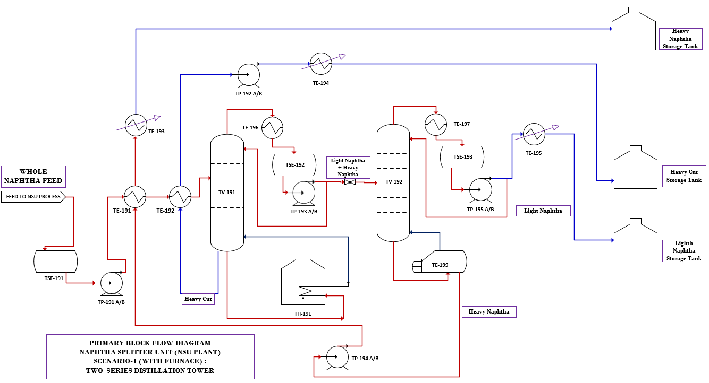
03
03
Figure 5 : Two Columns In Operation for HC Cut / Light Naphtha / Heavy Naphtha (SC-1- With Fire Heater)

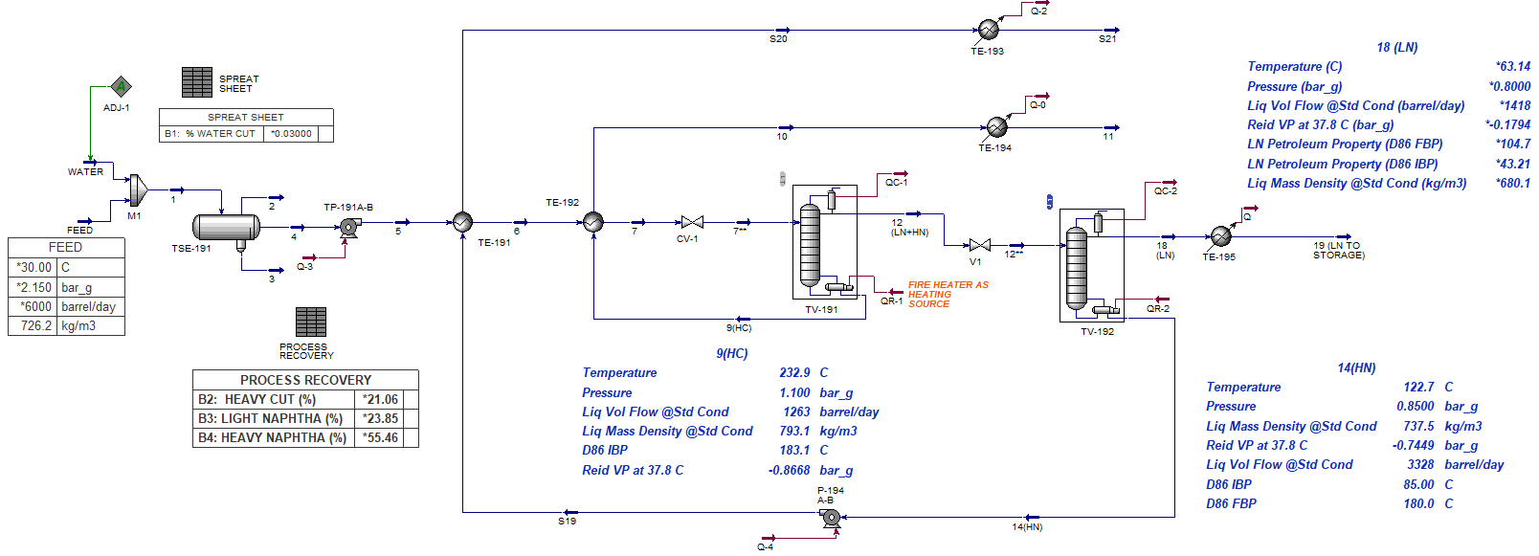
simulation is done by Hysys software version-15 as per below schematic:
Figure 6 :Hysys Simulation For Two Column With Fire Heater
03

TV-191 & TV-192 Column profiles for scenario-1 with fire heater is according to below :

Table 20 :TV-191 Column Product Profile With Fire Heater
TRAYS | Temp.  (°C) | Press.  (barg) | Vap.  (Kg/hr.) | Liq.  (Kg/hr.) | Feed Rate (kg/hr.) | Draw Rate  (kg/hr.) | Duty (kw)
TV-191(Cond.) | 95.19 | 1.00 |  | 20458.01 |  | 22731 | 4718
Tray-1# | 136.69 | 1.00 | 43189.14 | 22541.64
Tray-2# | 153.41 | 1.01 | 45272.77 | 23717.68
Tray-3# | 160.03 | 1.02 | 46448.8 | 23870.68
Tray-4# | 163.78 | 1.03 | 46601.81 | 23444.11
Tray-5# | 167.37 | 1.04 | 46175.23 | 63222.65 | 29369
Tray-6# | 190.13 | 1.05 | 56585.14 | 72551.9
Tray-7# | 199.72 | 1.06 | 65914.39 | 76324.62
Tray-8# | 205.67 | 1.07 | 69687.11 | 77798.65
Tray-9# | 211.18 | 1.08 | 71161.14 | 77856.22
Tray-10# | 218.45 | 1.10 | 71218.71 | 75027.63
TV-191(Reb.) | 232.91 | 1.10 | 68390.12 |  |  | 6637.7 | 5347

Table 21 :TV-192 Column Product Profile
TRAYS | Temp.  (°C) | Press.  (barg) | Vap.  (Kg/hr.) | Liq.  (Kg/hr.) | Feed Rate (kg/hr.) | Draw Rate  (kg/hr.) | Duty (kw)
TV-192(Cond.) | 61.94 | 0.80 |  | 4863.62 |  | 6473.5 | 1135
Tray-1# | 75.07 | 0.90 | 11337.16 | 5023.17
Tray-2# | 79.97 | 0.89 | 11496.71 | 4964.26
Tray-3# | 83.83 | 0.88 | 11437.8 | 4835.1
Tray-4# | 88.14 | 0.88 | 11308.65 | 4566.48 | 90.79
Tray-5# | 94.91 | 0.87 | 10949.23 | 27360.37 | 22640
Tray-6# | 96.84 | 0.87 | 11102.79 | 27608.5
Tray-7# | 99.12 | 0.86 | 11350.92 | 27899.4
Tray-8# | 101.92 | 0.86 | 11641.82 | 28239.53
Tray-9# | 105.6 | 0.85 | 11981.95 | 28626.47
Tray-10# | 111.31 | 0.85 | 12368.89 | 29030.98
TV-192(Reb.) | 122.72 | 0.85 | 12773.4 |  |  | 16258 | 1288
03
Product specification for TV-191 & TV-192 in scenario-1 with fire heater is as below :

Table 22 :Columns Product Properties for SC-1 With Furnace
Product Properties for SC-1 With Furnace
 | H.C | H.N | L.N
Temperature (°C) | 232.9 | 122.7 | 63.14
Pressure (Barg) | 1.10 | 0.85 | 0.8
Liq. Vol Flow @Std Cond (BSPD) | 1261 | 3324 | 1415
Liq. Mass Density @Std Cond (Kg/m3) | 793.1 | 737.5 | 680.1
Calculated D86 (IBP-FBP) | 180-285 (*) | 85-180 | 43.2-104.7(***)
Reid VP at 37.8 C (KPA) | 0.2 | 12.43 | 68.87
Recovery of product based on feed rate (%) (**) | 21.01 | 55.40 | 23.58

(*) Based on the assay data, the Heavy Naphtha cut has a target Final Boiling Point (FBP) of approximately 180°C. The subsequent Heavy Cut stream is expected to have an Initial Boiling Point (IBP) of approximately 180°C ± 3–5 °C. Consequently, a small overlap or transition region may exist between the two products. This transition region is considered normal refinery practice and allows the distillation unit to accommodate feedstock variations, operational fluctuations, and control limitations while maintaining the required product specifications and stable column operation.
(**)The difference between the assay cut distribution and the simulated product recovery is expected and is mainly caused by the fact that crude assay cuts are theoretical distillation fractions, whereas column products are actual operating products obtained from a real fractionation process because of near 20 °C between product specification is available as per client spec. request.
(***) Light Naphtha product starts at 43.2°C instead of 30°C because the column is working as actual recovering and very light hydrocarbons (approximately C5 and part of C6) is not available in Assay data based on RVP & SP.GR that is mentioned on Assay feed.

- Hysys Simulation for NSU plant with two column & Kettle Reboiler (SC-1:Case-1 & Option-2)
03

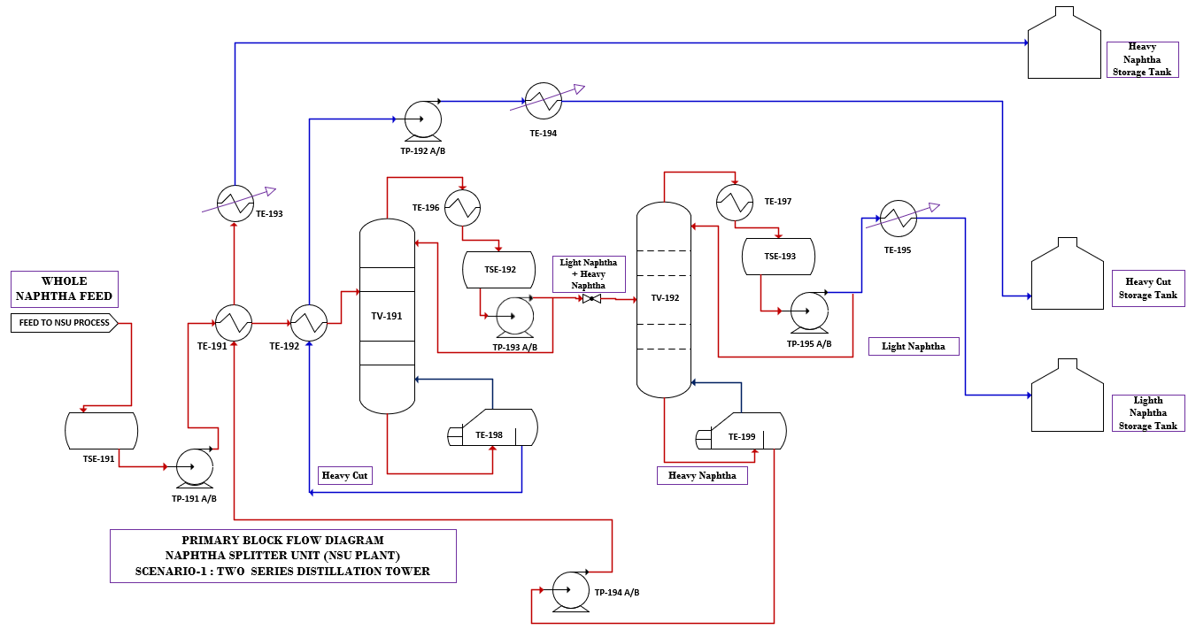
Below schematic diagram is shown primary block flow diagram for the Scenario-1 while two series columns are in operation with Kettle Reboiler:
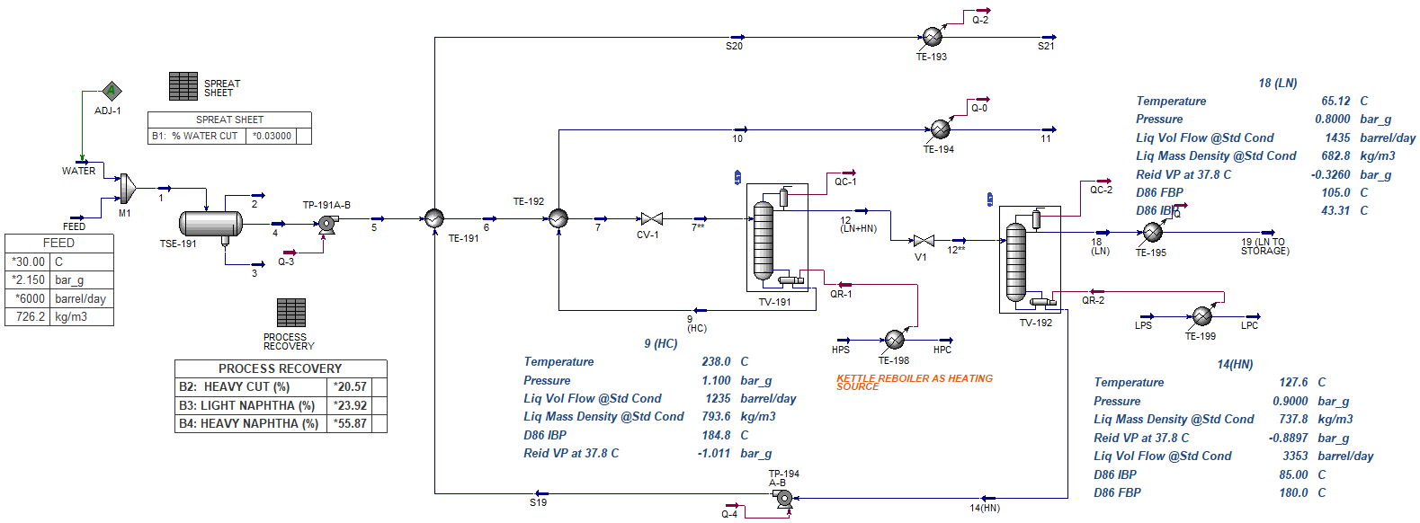
Figure 7 :Two Columns In Operation for HC Cut / Light Naphtha / Heavy Naphtha (SC-1-With Kettle Reboiler)
Figure 8 :Hysys Simulation for Two Column With Kettle Reboiler

03
TV-191 & TV-192 Column profiles for scenario-1 with kettle reboiler is according to below :

Table 23 :TV-191 Column Product Profile With kettle reboiler
TRAYS | Temp.  (°C) | Press.  (barg) | Liq.  (Kg/hr.) | Vap.  (Kg/hr.) | Feed Rate (kg/hr.) | Draw Rate  (kg/hr.) | Duty (kw)
TV-191(Cond.) | 98.53 | 1.00 | 34295.13 |  |  | 22878.65 | 6222.83
Tray-1# | 140.08 | 1.00 | 37984.66 | 57173.78
Tray-2# | 160.56 | 1.01 | 40926.69 | 60863.317
Tray-3# | 169.49 | 1.02 | 41878.25 | 63805.35
Tray-4# | 174.59 | 1.03 | 41727.13 | 64756.91
Tray-5# | 178.97 | 1.04 | 84569.99 | 64605.78 | 29368.63
Tray-6# | 197.75 | 1.05 | 95141.61 | 78080.01
Tray-7# | 205.68 | 1.06 | 98978.09 | 88651.63
Tray-8# | 210.99 | 1.07 | 100355.96 | 92488.11
Tray-9# | 216.22 | 1.08 | 100032.98 | 93865.98
Tray-10# | 223.46 | 1.1 | 95943.85 | 93543
TV-191(Reb.) | 238.03 | 1.1 |  | 89453.87 |  | 6489.97 | 6915.06

Table 24 :TV-192 Column Product Profile
TRAYS | Temp.  (°C) | Press.  (barg) | Liq.  (Kg/hr.) | Vap.  (Kg/hr.) | Feed Rate (kg/hr.) | Draw Rate  (kg/hr.) | Duty (kw)
TV-192(Cond.) | 65.12 | 0.8 | 1119.38 |  |  | 1435.1 | 1148.73
Tray-1# | 77.96 | 0.9 | 1138.79 | 2554.48
Tray-2# | 83.05 | 0.9 | 1115.09 | 2573.76
Tray-3# | 87.12 | 0.9 | 1076.97 | 2549.89
Tray-4# | 91.66 | 0.9 | 1006.37 | 2511.47 | 19.53
Tray-5# | 98.66 | 0.9 | 5809.61 | 2420.93 | 4760.26
Tray-6# | 100.72 | 0.9 | 5859.81 | 2463.49
Tray-7# | 103.15 | 0.9 | 5917.65 | 2513.01
Tray-8# | 106.11 | 0.9 | 5983.63 | 2570.01
Tray-9# | 109.99 | 0.9 | 6054.34 | 2635.05
Tray-10# | 115.96 | 0.9 | 6116.52 | 2704.6
TV-192(Reb.) | 127.55 | 0.9 |  | 2765.23 |  | 3352.61 | 1320.81

Product specification for TV-191 & TV-192 in scenario-1 with kettle reboiler is as below :

Table 25 :Columns Product Properties for SC-1 With kettle reboiler
03
Product Properties for SC-1 with kettle reboiler
 | H.C | H.N | L.N
Temperature (°C) | 238.03 | 127.6 | 65.12
Pressure (Barg) | 1.1 | 0.9 | 0.8
Liq. Vol Flow @Std Cond (BSPD) | 1232 | 3343 | 1425
Liq. Mass Density @Std Cond (Kg/m3) | 793.6 | 737.8 | 682
Calculated D86 (IBP-FBP) | 180-285 (*) | 85-180 | 43-105(***)
Reid VP at 37.8 C (KPA) | 0.21 | 12.35 | 68.73
Recovery of product based on feed rate (%) (**) | 20.53 | 55.71 | 23.75
(*) Based on the assay data, the Heavy Naphtha cut has a target Final Boiling Point (FBP) of approximately 180°C. The subsequent Heavy Cut stream is expected to have an Initial Boiling Point (IBP) of approximately 180°C ± 3–5 °C. Consequently, a small overlap or transition region may exist between the two products. This transition region is considered normal refinery practice and allows the distillation unit to accommodate feedstock variations, operational fluctuations, and control limitations while maintaining the required product specifications and stable column operation.
(**)The difference between the assay cut distribution and the simulated product recovery is expected and is mainly caused by the fact that crude assay cuts are theoretical distillation fractions, whereas column products are actual operating products obtained from a real fractionation process because of near 20 °C between product specification is available as per client spec. request.
(***) Light Naphtha product starts at 43°C instead of 30°C because the column is working as actual recovering and very light hydrocarbons (approximately C5 and part of C6) is not available in Assay data based on RVP & SP.GR that is mentioned on Assay feed.

SUMMARY RESULT FOR SCENARIO-1:

As per simulation study with Hysys software ver.15 ,below summary is reported :
  - In this configuration, Column-1 (TV-191) removes the combined Light Naphtha (LN) and Heavy Naphtha (HN) stream as the overhead product and produces Heavy Cut as the bottom product. The overhead stream from TV-191 is then fed to Column-2 (TV-192), which acts as the main fractionation splitter, separating the Light Naphtha (LN) and Heavy Naphtha (HN) product.
  - Advantages of Using Two Distillation Columns in Series
  - Operational Flexibility: Improved ability to achieve process targets and production capacity under varying feedstock compositions and flow rates.
  - Enhanced Process Control: Better control of operating conditions and product quality during feed variations.
  - Product Quality Management: Easier adjustment and maintenance of Light Naphtha, Heavy Naphtha, and Heavy Cut specifications during operation.
  - Independent Heat Integration: Separate condensers and reboilers for each column allow optimized heat duty distribution and energy management.
  - Improved Operator Control: Greater flexibility for operators to adjust column performance and respond to process disturbances.
  - Independent Reflux Control: Each column has its own reflux system, enabling better separation performance and adaptation to feed fluctuations.
  - Simplified Process Optimization: Product cut points can be adjusted through independent control of reboiler duties and reflux ratios.
  - Energy Management: Improved control of energy consumption through independent optimization of each column's operating conditions.
  - Superior Separation Efficiency: Enhanced fractionation sharpness resulting in better product purity and cut-point control.
  - Maintenance Flexibility: Easier isolation, troubleshooting, inspection, and maintenance of individual columns without affecting the entire separation system.
  - Future Expandability: Easier implementation of capacity debottlenecking or process modifications compared to a single-column configuration.
  - Improved Reliability: Reduced operational risk through independent separation control of each stage.

  - Summary report when Using Fire Heater as Heating Medium,below data is calculated when the fire heater is considered as column heater :
03
Table 26 : Simulation result table With Fire Heater (TV-191 & TH-191)
Simulation With Fire Heater (TV-191 & TH-191)
Column  Feed Rate : 6000 BPSD | Column Top Tray-1# Temp. (°C) : | 136.69 | Column ID (mm): (**) | TOP : 1800 / BTM :2300
Column  Feed Rate : 6000 BPSD | Column BTM Tray-n # Temp. (°C) : | 218.45 | Column Height (mm): | 24000
Column  Feed Rate : 6000 BPSD | Condenser Temp. (°C) : | 95.19 | Condenser Duty (KW) : | 4718 x 1.2
Column  Feed Rate : 6000 BPSD | Heater Temp. (°C) : | 232.91 | Heater Duty (KW) : | 5347 x 1.2
Column  Feed Rate : 6000 BPSD | Column TOP / BTM Press. (Barg) | 1.0 / 1.1
Product Flow Rate for Case-1 : Column With Fire Heater (TV-191 & TH-191)
Feed Rate : 6000 BPSD | TOP Product : ( LN+HN) | 4739 BPSD
Feed Rate : 6000 BPSD | BTM Product : ( HC) | 1261 BPSD
Feed Rate : 6000 BPSD | Product Spec : (only for Heavy Cut) | Liq. Mass Density @Std Cond :793.1
Conclusion :
  - If we use the fire heater as heating medium the safety criteria and plot area limitation shall be considered.
  - In this case we need source of fuel gas and BMS system and more control systems that is costly
  - Safety concept and EIA study with emission /dispersion effect need to note by client that is costly
  - (**) size (ID _{X} TL-TL) and no.of actual tray will be finalized during detail data sheet.

Table 27: HC Product Cut Specification With Fire Heater
03
Cut Data | HC Product Specification
BTM Temperature © | 232.9 | Smoke Pt (mm) | 25.337
Pressure (Barg) | 1.10 | Freeze Point (°C) | -21.19
Liq. Vol Flow @Std Cond (BSPD) | 1261 | Cloud Point (°C) | -29.24
Liq. Mass Density @Std Cond (Kg/m³) | 793.1 | Pour Point (°C) | -57.34
Petroleum Property (D86 FBP) | 284+ | Cetane Index - ASTM-D4737 | 52.252
Petroleum Property (D86 IBP) | 180 | Cut Yield by Wt. (%) | 16.44
Calculator (Reid VP at 37.8 C) (KPA) | 0.2 | Mercaptan Sulfur by Wt. (%) | 0.1183
Cut Yield By Vol (%) | 16.273% | Flash point (°C) | 82.28
Sulfur By Wt. (%) | 0.2153
Watson K | 12.08

  - Summary report when Using kettle Reboiler as Heating Medium, below data is calculated when the kettle Reboiler is considered as column heater :

Table 28 : Simulation Result With Reboiler (TV-191 & TE-198)
03
Simulation With Reboiler (TV-191 & TE-198)
Column  Feed Rate : 6000 BPSD | Column Top Tray-1# Temp. (°C) : | 140.08 | Column ID (mm): (**) | TOP : 1675 / BTM :2100
Column  Feed Rate : 6000 BPSD | Column BTM Tray-n # Temp. (°C) : | 223.46 | Column Height (mm): | 24000
Column  Feed Rate : 6000 BPSD | Condenser Temp. (°C) : | 98.53 | Condenser Duty (KW) : | 6222.8.3 x 1.2
Column  Feed Rate : 6000 BPSD | Reboiler Temp. (°C) : | 238.03 | Reboiler Duty (KW) : | 6915.06 x 1.2
Column  Feed Rate : 6000 BPSD | Column TOP / BTM Press. (Barg) | 1.0 / 1.1
Product Flow Rate for Case-1 : Column With Reboiler (TV-191 & TE-198)
Feed Rate : 6000 BPSD | TOP Product : ( LN+HN) | ~4768 BPSD
Feed Rate : 6000 BPSD | BTM Product : ( HC) | ~1232 BPSD
Feed Rate : 6000 BPSD | Product Spec : (only for Heavy Cut) | Liq. Mass Density @Std Cond : 793.6 Kg/m³
Conclusion :
  - By considering reboiler we reach to qualification & process flow specification as per above data with low cost rather than fire heater with more flexibility.
  - If we use the reboiler as heating medium the HPS will be provider to kettle reboiler with P : 39 barg (NOR) & T : 350 °C (NOR) with primary estimated rate is : 12625.32 x 1.2 Kg/hr.
  - Kettle reboiler type is selected AKU TEMA type (TEMA Type will be finalized during detail datasheet.)
  - (**) size (ID _{X} TL-TL) and no.of actual tray will be finalized during detail data sheet.

Table 29: HC Product Cut Specification With Kettle reboiler
03
Cut Data | HC
BTM Temperature (C) | 238.03 | Smoke Pt (mm) | 25.37
Pressure (Barg) | 1.1 | Freeze Point (°C) | -27.17
Liq. Vol Flow @Std Cond (BSPD) | 1232 | Cloud Point (°C) | -16.35
Liq. Mass Density @Std Cond (Kg/m³) | 793.6 | Pour Point (°C) | -42.75
Petroleum Property (D86 FBP) | 284+ | Cetane Index - ASTM-D4737 | 52.20
Petroleum Property (D86 IBP) | 180 | Cut Yield by Wt. (%) | 20.37
Calculator (Reid VP at 37.8 C) (KPA) | 0.21 | Mercaptan Sulfur by Wt. (%) | 0.19
Cut Yield By Vol (%) | 20.53 % | Flash point (°C) | 83.06
Sulfur By Wt. (%) | 0.2253
Watson K | 12.10

  - Second Tower (TV-192) specification for scenario-1 (option 1 & 2 ) is according to below:

Table 30 : Product Flow Rate for Second Column (TV-192) (OPTION-1)
Simulation Report For Second Tower (TV-192 & TE-199)
Column  Feed Rate : 4739 BPSD | Column Top Tray-1# Temp. (°C) : | 61.94 | Column ID (mm): (**) | TOP : 1300 / BTM :2100
Column  Feed Rate : 4739 BPSD | Column BTM Tray-n # Temp. (°C) : | 111.31 | Column Height (mm): | 22000
Column  Feed Rate : 4739 BPSD | Condenser Temp. (°C) : | 61.94 | Condenser Duty (KW) : | 1135 x 1.2
Column  Feed Rate : 4739 BPSD | Heater Temp. (°C) : | 122.72 | Heater Duty (KW) : | 1288 x 1.2
Column  Feed Rate : 4739 BPSD | Column TOP / BTM Pressure (Barg) | 0.8 / 0.85
Product Spec : (for Light Naphtha) |  | Liq. Mass Density @Std Cond :680.1 Kg/m³
Product Spec : (for Heavy Naphtha) |  | Liq. Mass Density @Std Cond :737.5 Kg/m³
Product Spec : (Reid VP at 37.8 C for Light Naphtha) |  | 68.87 kPa
LN Prod. Spec. (ASTM D-86) : |  | Calculated IBP : 43 °C & Calculated FBP : 105 °C
HN Prod. Spec. (ASTM D-86) : |  | Calculated IBP : 85 °C & Calculated FBP : 180 °C
Feed Rate : 4739 BPSD | TOP Product : ( LN) | 1415 BPSD
Feed Rate : 4739 BPSD | BTM Product : ( HN) | 3324 BPSD
Conclusion :
  - (**) size (ID _{X} TL-TL) and no.of actual tray will be finalized during detail data sheet.

Table 31 : Product Flow Rate for Second Column (TV-192) (OPTION-2)
03
Simulation Report For Second Tower (TV-192 & TE-199)
Column  Feed Rate : 4768 BPSD | Column Top Tray-1# Temp. (°C) : | 77.96 | Column ID (mm): (**) | TOP : 1250 / BTM :2000
Column  Feed Rate : 4768 BPSD | Column BTM Tray-n # Temp. (°C) : | 115.96 | Column Height (mm): | 22000
Column  Feed Rate : 4768 BPSD | Condenser Temp. (°C) : | 65.12 | Condenser Duty (KW) : | 1148.73 x 1.2
Column  Feed Rate : 4768 BPSD | Reboiler Temp. (°C) : | 127.55 | Reboiler Duty (KW) : | 1320 x 1.2
Column  Feed Rate : 4768 BPSD | Column TOP / BTM Pressure (Barg) | 0.8 / 0.9
Product Spec : (for Light Naphtha) |  | Liq. Mass Density @Std Cond :680.5 Kg/m³
Product Spec : (for Heavy Naphtha) |  | Liq. Mass Density @Std Cond :737.8 Kg/m³
Product Spec : (Reid VP at 37.8 C for Light Naphtha) |  | 68.73 kPa
LN Prod. Spec. (ASTM D-86) : |  | Calculated IBP : 43 °C & Calculated FBP : 105 °C
HN Prod. Spec. (ASTM D-86) : |  | Calculated IBP : 85 °C & Calculated FBP : 180 °C
Feed Rate : 4768 BPSD | TOP Product : ( LN) | 1425 BPSD
Feed Rate : 4768 BPSD | BTM Product : ( HN) | 3343 BPSD
Conclusion :
  - (**) size (ID _{X} TL-TL) and no.of actual tray will be finalized during detail data sheet.

  - Kettle Reboilers vs. Fire Heater advantage and disadvantage is according to below:

Table 32: Kettle Reboilers vs. Fire Heater advantage and disadvantage
Kettle Reboilers vs. Fire Heater provided form NSU process
Fired Heater Advantages & Disadvantage | Kettle Reboiler with HPS Advantages & Disadvantage
CAPEX : costly  The fire heater is expensive and need more accessories like as  - Fuel gas system  - Burners  - Stack  - Combustion air fans  - Fuel control system  - Fire and gas protection systems  - Safety limitation & more Plot area and more space requirement | CAPEX : moderate costly  - A kettle reboiler is usually less expensive than Fired heater  - Plot area and low space requirement  - Better Safety  - No flame requirement therefore no need to Burner trips, Flame failure, Tube overheating, Fire hazards
Much Higher Temperature Capability  This is the biggest advantage using A fired heater can easily deliver: (300 ~ 400 +) °C  In case of the column bottoms require high temp.  a fired heater may be the only option. | Temperature limitation for product specification based on sensitivity tray  HPS (39 barg) provides a saturation temperature roughly in the 250°C range and lower tray temperature depend on HPS and reboiler vaporization .
Fire heater boil up  - Higher Potential Boil-Up  - Naphtha Splitting Unit require extremely high vapor generation as per process data and simulation and steam-side ΔT may become limiting.  - A fired heater can continue increasing duty and product target specification. | Kettle reboiler boil-up  Steam condenses on the tube bundle and transfers heat to the liquid pool.  Characteristics:  - Heat input is indirect.  - Steam temperature is nearly constant.  - Vapor generation is relatively uniform.  - Excellent temperature control.
Control  - Better product generation  - Lack of Steam or steam rate is limited in process,  - Need more system control and BMS system  - Better Product Recovery  - better HC Cut & Heavy Naphtha splitting in coverage cut point | Control  - Better Temperature Control  - Steam condenses at nearly constant temperature. This provides Stable column operation & Stable reflux requirements  - Easier product quality  - Control Steam generation is constrained
Maintenance  fired heater maintenance including Burners, Refractory, Stack inspection, Tube inspection  Decoking, soot blower requirement (if available) | Maintenance  Typical kettle maintenance Bundle cleaning & Steam trap maintenance & Valve maintenance (easy maintenance)
Energy Integration  Better for pinch activity and temperature follow up based on product specification | Energy Integration  No additional fuel system required, Easier heat integration and Simpler operation but lower product specification
FINAL SUMMARY
- It is recommended to using two tower that is working series with together and kettle reboiler integrated with first column is more economical and flexible with same performance rather than fire heater.
- based on necessity of plot area limitation & product spec requirement using kettle reboiler for first column is recommended.
- steam supply condition for kettle reboiler is 39 barg / 350°C, HP steam temperature available to the reboiler and will provide sufficient driving force with more heat flux on exchanger area. In that case, using kettle reboiler give the same result and product specification rather than fire heater so can be more economical based on product density and IBP/FBP requirement.
- Below table is shown the comparison of kettle reboiler and fire heater as per above table
Item | Kettle Reboiler (HPS) | Fired Heater
Heat source | Condensing steam | Combustion
Boil-up control | Steam flow | Firing rate
Maximum achievable boil-up | Moderate | High
Temperature capability | Limited by steam | Very high
Stability | Excellent | Good
Maintenance | Low | Higher
Coking risk | Very low | Higher
Product Specification | Good | Good
- The scenario study has been conducted based on the project requirements and specifications. Therefore, the necessity of a reboiler versus a fired heater has been studied and simulated. All relevant data is provided in the tables. Based on lower cost and the easy operation and process specifications, we recommend using kettle reboiler as the primary option; threfore,option-2 is recommended and this option involves lower costs and not requires strict safety limitations and criteria.

SC-1 : CASE-2 : IN RANGE FEED
In this project, the process has been evaluated under different feed conditions (i.e., in-range and off-range feed scenarios). Under certain off-range feed conditions (i.e. heavy cut is available on feed assay characteristics), it is recommended two towers (fractionation and splitting) working with together.
If the feed included of Heavy and light naphtha it is possible to bypass some equipment and using only second tower TV-192 as splitter. This bypassed activity should be without affecting the overall design basis.
In range feed does not included any heavy cut and second tower will be operated for light and heavy naphtha splitting from top and bottom . In such cases, the feed composition have heavy cut therefore, it may be possible to operate two towers working as series configuration.
Based on the feed quality and operation team request one of the columns may be bypassed as per following review and approval by the Process Department.

- When the feed composition and boiling range are not within the range, the process shall operate both towers TV-191 and TV-192 operating in series.
Off-range feed refers to feedstock that is heavier than the design basis or heavy cut is available in feed specification .In most anticipated of cases, the feed is expected to be lighter than the project design basis, resulting in a reduced quantity of Heavy Cut product or, in some cases, no Heavy Cut available in feed data..
At this situation :
- The first column TV-191 may be bypassed.
- The second column TV-192 remains in operation.
- TV-192 functions as the main splitter column to achieve the required product specifications.
The most critical consideration for the bypass scenario is verification of equipment sizing and process capacity adequacy.
It shall be demonstrated that bypassing TV-191 does not adversely effect on:
- TV-192 hydraulic capacity
- TV-192 thermal performance
- Heat exchangers duties
- Pump capacities
- Control valve sizing
- Final product specifications

Accordingly, all heat exchangers, pumps, control valves, and other associated equipment shall be designed and sized to accommodate both normal operation and bypass operation. The process design shall ensure that operation with the first column bypassed does not result in any deterioration of product quality, reduction in process performance, or inability to meet the specified product specifications. in case of variation feed source it is recommended to size all equipment and related piping system with appropriated over design factor and recommend to consider 20% over design on flow. A process capacity adequacy assessment shall be performed to confirm that the downstream equipment and the second column have sufficient hydraulic, thermal, and operational capacity to process the full feed rate under bypass operating conditions.

As shown in the first block diagram and design case, the feed is first fed into a 3 Phase Separator (provided with gas blanket) so that if there is water in the feed. In the next stage , the feed is pumped by a pump after passing through a Heat Exchanger that acts as a feed preheater. By removing the first tower through the bypass valve, the Unit total feed , which is a mixture of light and heavy Naphtha, is transferred directly to the second tower, where the light Naphtha will be separated from the upper part of the tower and heavy Naphtha from the lower part of the tower and are transferred to the storage tanks at a temperature of 38 degrees Celsius and a pressure of 6 bar.(will be finalized after final destination have been specified.)
03

in this case, if the feed source assay data is not included heavy cut, first column will be by-passed and total feed after passing through the first heat exchanger will be conducted to the second tower for splitting light & heavy Naphtha in case of no heavy cut present in feed.
some of the equipment in this case-2 will be put in out of service as below:

- TE-192: Second Preheater Heat Exchanger
- TV-191 : Primary Distillation Tower (HC Cut Splitter)
- TE-196 : First Tower Air Cooled Heat Exchanger
- TE-198 : First Tower Kettle Reboiler
- TP-192 A/B: HC Cut Transfer Pump
- TE-194: HC Cut Cooler Heat Exchanger
- TP-193 A/B: TV-191 Reflux Pump
- TSE-192 : TV-191 Reflux Condenser Drum
03
The not used equipment is highlighted in below schematic in red color.
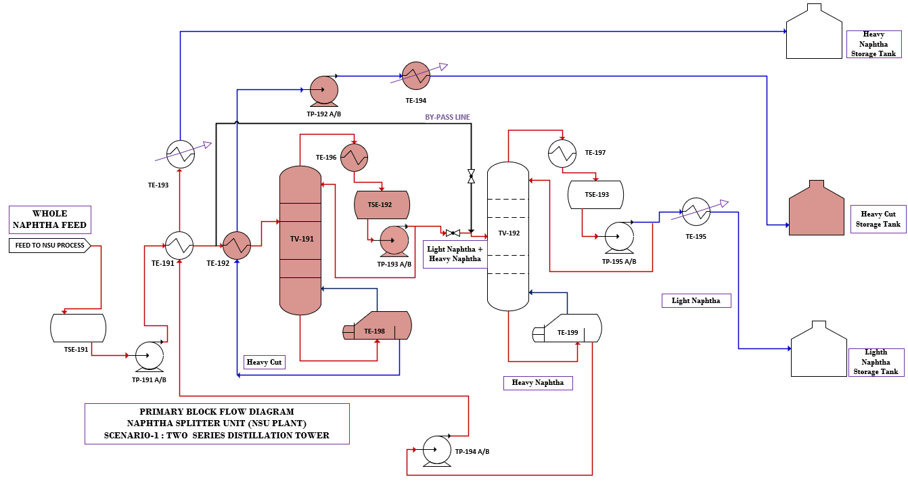
Figure 9 : first Column is by-passed & second column is in service for LN/HN Splitting (SC-1: Case-2)

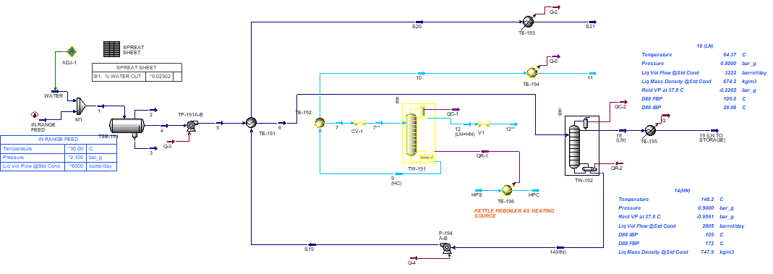
Figure 10 : Hysys Simulation for By-Passed Case For LN/HN Splitting (SC-1: Case-2)
based on lack of in range assay in our design basis data is extracted from TV-191 top tower as in range feed and equivalent in range assay is shown in below table . new simulation study is done for case-2 and as an option the inlet feed range characterization is as below :
 | Feed Characteristic  Liq Vol Flow @Std Cond : 6000 BSPD  T: 30 °C  P: 2.1 barg
  Liquid Volume  Percent (%) | Temperature (°C)
  0 | 30
  5 | 45
  10 | 67.5
  15 | 69
  20 | 71.4
  30 | 79.3
  40 | 88.1
  50 | 98.4
  60 | 109.1
  70 | 119.9
  80 | 130.4
  90 | 144.8
  100 | 180

Bellow table is shown allowable in-range mixed Naphtha characteristics for the Naphtha Splitter (second column), along with the maximum permissible feed rate to the unit under this case and summary report when using bypassed case is according to below:
Table 33 :by-pass case and allowable in-range mixed Naphtha TV-192 Column Product Profile
03
TRAYS | Temp.  (°C) | Press.  (barg) | Vap.  (Kg/hr.) | Liq.  (Kg/hr.) | Feed Rate (kg/hr.) | Draw Rate  (kg/hr.) | Duty (kw)
TV-192_Condenser | 64.4 | 0.80 | 7051.23 |  |  | 14390.22 | 2270.84
1__TS-1 | 88.9 | 0.80 | 7481.36 | 21441.45
2__TS-1 | 95.6 | 0.81 | 7463.20 | 21871.58
3__TS-1 | 98.8 | 0.82 | 7328.60 | 21853.42
4__TS-1 | 101.3 | 0.83 | 7105.23 | 21718.82
5__TS-1 | 104.1 | 0.84 | 41870.50 | 21495.45 | 28286.04
6__TS-1 | 115.0 | 0.86 | 44122.74 | 27974.67
7__TS-1 | 122.4 | 0.87 | 45609.40 | 30226.92
8__TS-1 | 128.2 | 0.88 | 46656.23 | 31713.57
9__TS-1 | 133.6 | 0.89 | 47441.08 | 32760.40
10__TS-1 | 139.9 | 0.90 | 48065.11 | 33545.25
TV-192_Reboiler | 148.2 | 0.90 |  | 34169.28 |  | 13895.83 | 3014.49

Table 34 : Simulation Result for allowable in-range feed With Reboiler (TV-192 & TE-198)
03
By-passed Column Simulation With Reboiler (TV-192 & TE-198)
Column  Feed Rate : 6000 BPSD | Column Top Tray-1# Temp. (°C) : | 88.87 | Column ID (mm): (**) | TOP : 1675 / BTM :2000
Column  Feed Rate : 6000 BPSD | Column BTM Tray-n # Temp. (°C) : | 139.9 | Column Height (mm): | 24000
Column  Feed Rate : 6000 BPSD | Condenser Temp. (°C) : | 64.37 | Condenser Duty (KW) : | 2271 x 1.2
Column  Feed Rate : 6000 BPSD | Reboiler Temp. (°C) : | 148.2 | Reboiler Duty (KW) : | 3014 x 1.2
Column  Feed Rate : 6000 BPSD | Column TOP / BTM Press. (Barg) | 0.8 / 0.9
Column  Feed Rate : 6000 BPSD | TOP Product : ( LN) | ~3222 BPSD
Column  Feed Rate : 6000 BPSD | BTM Product : ( HN) | ~2775 BPSD
LN Prod. Spec. (ASTM D-86) : |  | Calculated IBP : 28.06 °C & Calculated FBP : 105 °C
LN. Liq Mass Density @Std Cond: |  | 674.2 Kg/m3
Reid Vapor Pressure: |  | 78.6 KPA
HN Prod. Spec. (ASTM D-86) : |  | Calculated IBP : 105 °C & Calculated FBP : 172 °C
HN. Liq Mass Density @Std Cond: |  | 747 Kg/m3
Note :
The preliminary assessment indicates that the same tower dimensions may be utilized for both in-range and off-range feed conditions, provided that hydraulic and process capacity evaluations confirm acceptable operation. For the anticipated off-range feed scenario, which is expected to be lighter than the design basis feed, the vapor and liquid traffic within the column are generally lower than those of the design case. Therefore, it is recommended to use same size of tower diameter with tray detail checking and hydraulic evaluation.

- SCENARIO 2: USING ONLY ONE TOWER WITH SIDE DRAW
In this scenario assuming the feed is not heavy, only one tower is used to separate light and heavy naphtha. As shown in the first diagram of this design, the feed is first fed into a 3 Phase Separator (with gas blanketing) so that if there is water in the feed, it can be separated. In the next stage, the feed is pumped by a pump after passing through the heat exchanger, which acts as a feed preheater, enters the main tower and approximately their desired products are light Naphtha, heavy Naphtha and Heavy cut.
03
Main Equipments for this scenario-3 is according to the below items:

- TSE-191 : Three Phase Separator
- TP-191 A/B: Crude Transfer Pump
- TE-191 : First Pre-Heater Heat Exchanger
- TE-192: Second Preheater Heat Exchanger
- TV-191 : Primary Distillation Tower (HC Cut Splitter)
- TE-193 : First Tower Air Cooled Heat Exchanger
- TE-194 : First Tower Kettle Reboiler
- TP-192 A/B: HC Cut Transfer Pump
- TE-195: HC Cut Cooler Heat Exchanger
- TP-193 A/B: Heavy Naphtha (HN) Cut Transfer Pump
- TE-196: Heavy Naphtha (HN) Cut Cooler Heat Exchanger
- TE-197: Light Naphtha (HN) Cut Cooler Heat Exchanger
- TSE-192 : TV-191 Reflux Condenser Drum

in this scenario only one fractionation tower will be in service and Unit’s feed after passing through the first heat exchanger will be heated up. At this scenario light Naphtha from top and heavy cut from bottom of the tower will be splitted. Also heavy Naphtha will be extracted by side draw at mid of the tower.

Below schematic diagram shows the fractionation tower configuration.
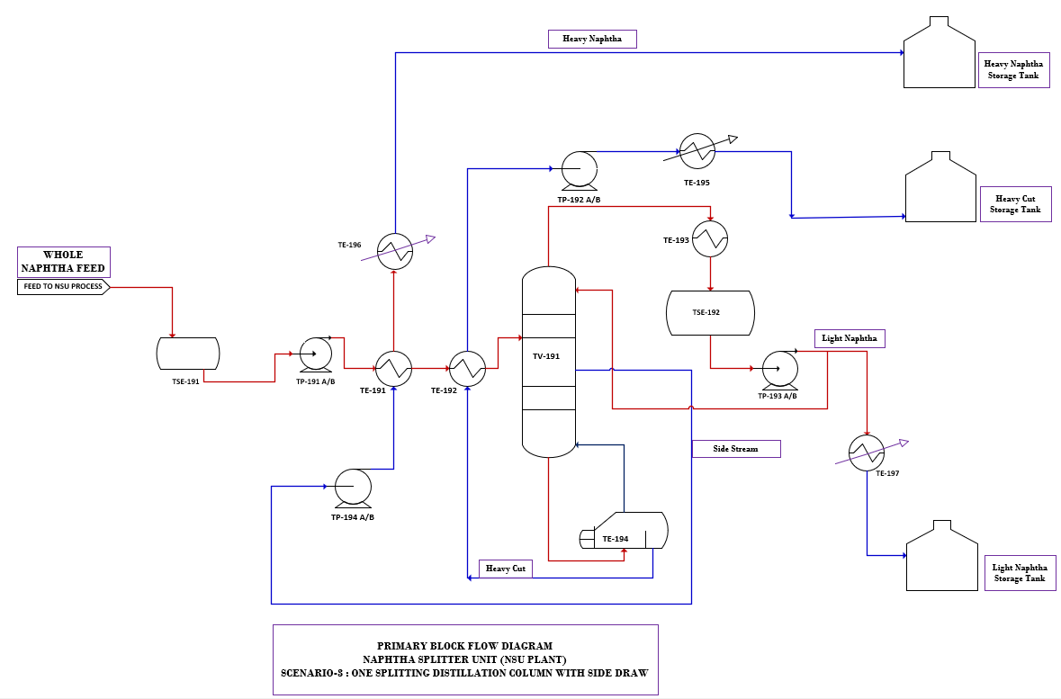
Figure 11 : only one tower with side draw Assuming (Scenario-2)
03

Simulation Schematic For Scenario-2 :
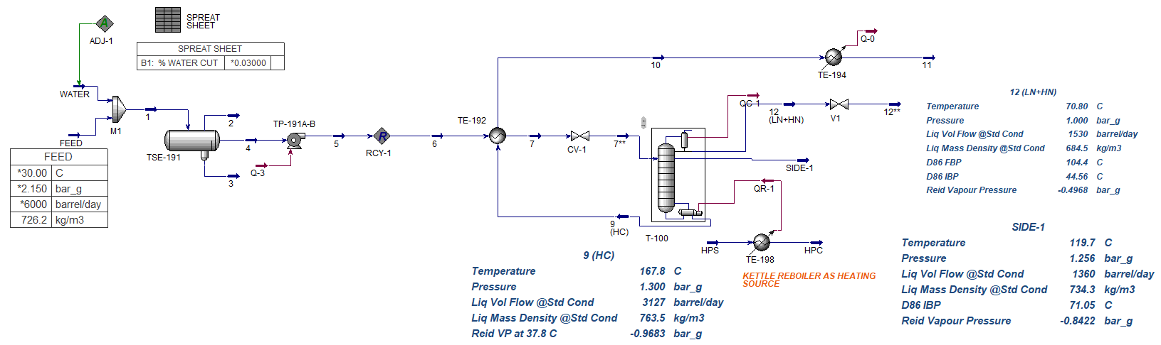
Figure 12 : Hysys simulation for Scenario-2

Table 35 : simulation report for Scenario-3
03
Product Flow Rate for Scenario-3
TV-191 | Feed to Column Rate : | 6000 BPSD
TV-191 | Reboiler Duty (KW) | 2550 x 1.2
TV-191 | TOP Product : ( LN) | 1535 BPSD
TV-191 | Side Stream Product : ( HN) | 1360 BPSD
TV-191 | BTM Product : ( HC) | 3105 BPSD
TV-191 | Product Spec : (for Light Naphtha) | Liq. Mass Density @Std Cond :684 Kg/m3
TV-191 | Product Spec : (for Heavy Naphtha) | Liq. Mass Density @Std Cond :734.4 Kg/m3
TV-191 | Product Spec : (for Heavy Cut) | Liq. Mass Density @Std Cond :763.6 Kg/m3
TV-191 | Product Spec : ((Reid VP at 37.8 C for Light Naphtha) | 51 kPa
TV-191 | LN Prod. Spec. (ASTM D-86) : | Calculated IBP : 45.2°C & Calculated FBP : 104.5 °C
TV-191 | HN Side Prod. Spec. (ASTM D-86) : | Calculated IBP : 80 °C & Calculated FBP : 180 °C
TV-191 | HC Prod. Spec. (ASTM D-86) : | Calculated IBP : 180 °C & Calculated FBP : 284 °C

CONCLUSION
- The main advantage of using a two-distillation columns (TV-191 & TV-192)) for splitting light and heavy naphtha and heavy cut can be quality improvement of the light and heavy Naphtha Products. This is primarily achieved by combining the operation of two separate distillation columns, which inherently eliminates process inefficiencies.
- As per process simulation, two configurations are considered i.e.
1) Naphtha splitting with two series column
2) using one individual column with side draw
03
as per below table the data study shown advantage and disadvantage of column configurations.

Table 36 : Comparison of Scenarios 1 and 2
Two Distillation Columns (Series Arrangement) | Using one individual column with side draw
Column 1: Removes LN+HN at top and heavy cut at BTM.  Column 2: HN Splitter (splits LN and HN)  (Prefractionation + Main Splitter) | One main fractionation column  One side draw for Heavy Naphtha  One bottom product as HC Purity
flexibility operation and capacity based on feed variation | Limited for feed variation and product specification  (less good quality separation for Heavy naphtha with one column in off range feed)
increasing control system in case of feed variation | less control on tower operation & upset production
management product cut specification during the operation | less tower management based on process failure
Individual condensers and reboilers based on product and system control | Reboiler and condenser flux limitation
Separate reflux for each column systems | One reflux and low control especially on Top & BTM product
Higher capital cost and need more plot and spacing | less capital cost and need less plot and spacing
Simple control flexibility based on reboiler and reflux rate control | less control flexibility
Operational flexibility: high | Operational flexibility: low
Energy Consumption: High (Steam, FG / Liquid Oil)* | Energy Consumption: low (need MP steam)
Separation Sharpness: excellent | Separation Sharpness: low
Maintenance: Easier isolation | Shutdown affects all products lost
Product Quality Comparison
Light Naphtha RVP Control: excellent | Light Naphtha RVP Control: less
HN Endpoint Control: excellent | HN Endpoint Control: less (overlap and coverage cut points between HN & LN will happen)
Heavy Cut Purity: excellent | Heavy Cut Purity: less (overlap and coverage cut points between LN & HN will happen)
Over fractionation Risk: low | Over fractionation Risk: high
Wide crude variability  ✔ Strict LN RVP control required  ✔ HN is reformer feed  ✔ Future expansion planned  ✔ High operational flexibility required | Limited as feed variation and product specification  (it is tight to meet the process product qualification with one tower especially for off range feed)
As per simulation report the two-column configuration provides:
- Superior fractionation sharpness
- Higher operational flexibility
- Better handling of feed composition variation
- Easier control and troubleshooting

- Based on water cut available in the feed assay data, it is recommended to consider three phase separator with adequate internal for water removal and feed will be passed through the feeding pump to TV-191 in the fractionating stage.
- Based on the Owner provided feed data (Assay data) and simulation result data, technical data will be calculated accordingly for two Distillation Columns (Series Configuration) and it is recommended to use kettle reboiler as first choice. Detail and utility consumption for reboiler will be finalized in detail stage.

- Primary utility consumption is as below, The primary utility consumption is summarized below. The reported utility requirements represent the worst-case operating scenario; however, the detailed consumption figures for each utility will be provided in the relevant utility design documents.
03

Table 37 : PRIMARY UTILITY CONSUMPTION LIST
PRIMARY UTILITY CONSUMPTION LIST FOR NAPHTHA SPLITTER PACKAGE
 | Item | UTILITY SERVICE | FLOW |  | PRESSURE |  | TEMPERATURE
 | Item | UTILITY SERVICE | Normal | Design | Normal | Maximum | Normal | Maximum
 | Item | UTILITY SERVICE | kg/hr |  | (Barg) | (Barg) | [°C] | [°C]
COOLING WATER DEMAND (NOTE-1)
A) | 1 | Cooling Water for TE-193 | 11440 | 13728. | 2.8 | 4 | 29 | 30
A) | 2 | Cooling Water for TE-194 | 9003 | 10803.6
A) | 3 | Cooling Water for TE-195 | 14971 | 17965
TOTAL |  |  | 35414 | 42497
- 20% over design on flow will be considered for cooling water demand rate.

 | Item | UTILITY SERVICE | FLOW |  | PRESSURE |  | TEMPERATURE
 | Item | UTILITY SERVICE | Normal | Design | Normal | Maximum | Normal | Maximum
 | Item | UTILITY SERVICE | kg/hr |  | (Barg) | (Barg) | [°C] | [°C]
STEAM DEMAND (NOTE-1)
 | 1 | HP PRESSURE STEAM (HPS) for TV-191 | 12625.3 | 15150.3 | 39 | 40 | 350 | 395
 | 2 | LP PRESSURE STEAM (LPS) for TV-192 | 2204 | 2644.8 | 3.5 | 4 | 150 | 180
TOTAL
- 20% over design on flow will be considered for steam demand rate.

FUEL GAS DEMAND-(NOTE-1)
 | Item | UTILITY SERVICE | FLOW |  | PRESSURE |  | TEMPERATURE
 | Item | UTILITY SERVICE | Normal | Design | Normal | Maximum | Normal | Maximum
 | Item | UTILITY SERVICE | [Nm3 / h] |  | (barg) | (barg) | [°C] | [°C]
 | 1 | FG (Fuel Gas ) | 800  (only for fire heater case) |  | 3.4 | 4.8 | 49 | 85
- this case only applicable when fire heater is considered for TV-192 .fuel gas analysis & burner efficiency will be finalized in detail stage phase

NITROGEN DEMAND (NOTE-1)
 | Item | UTILITY SERVICE | FLOW |  |  | PRESSURE |  | TEMPERATURE
 | Item | UTILITY SERVICE | Normal | Design |  | Normal | Maximum | Normal | Maximum
 | Item | UTILITY SERVICE | [Nm3 / h] |  |  | (barg) | (barg) | [°C] | [°C]
 | 1 | N2(Nitrogen) - Continuous cons. for TTK-191 | 0 |  |  | 2 | 3 | 10 | 50
 | 2 | N2(Nitrogen) - Continuous cons. for TTK-192 | 0 |  |  | 2 | 3 | 10 | 50
 | 3 | N2(Nitrogen) - intermittent cons. for TTK-191 & TTK-192 | [300] |  | [350] | 2 | 3 | 10 | 50
 | 4 | N2(Nitrogen) - Continuous cons. For TSE-191 | 25 |  | 28 | 2 | 3 | 10 | 50
- N2 gas analysis & qualification will be finalized in detail stage phase

ELECTRICAL POWER DEMAND - (NOTE-1)
 | Item | UTILITY SERVICE | QTY | Power Form One Pump |  | REMARK
 |  |  |  | Normal | Design
 |  |  |  | KW
 | 1 | Powe for Pump TP-191 A/B | 2 | 5.7 | 5.7 x 1.2 | Pump efficiency will be updated by vendor  Electricity : 3 phase- 400 V-50 HZ
 | 2 | Powe for Pump TP-192 A/B | 2 | 0.365 | 0.365 x 1.2
 | 3 | Powe for Pump TP-193 A/B | 2 | 0.35 | 0.35 x 1.2
 | 4 | Powe for Pump TP-194 A/B | 2 | 2.18 | 2.18 x 1.2
 | 5 | Powe for Pump TP-195 A/B | 2 | 3.01 | 3.01 x 1.2
 | 6 | Air Cooler Fans Total Power | 16 | 200 | 200 X 1.2 | (Note-3)
 | TOTAL |  | 26 | 211.6 | 211.6 x1.2
INSTRUMENT AIR & PLANT AIR DEMAND-(NOTE-2)
 | Item | UTILITY SERVICE | FLOW |  | PRESSURE |  | TEMPERATURE
 | Item | UTILITY SERVICE | Normal | Design | Normal | Maximum | Normal | Maximum
 | Item | UTILITY SERVICE | [Nm3 / h] |  | (kg/cm2g) | (kg/cm2g) | [°C] | [°C]
 | 1 | Instrument Air - Continuous | 15 | 20.3 | 4 | 4 | 10~32 | 70
 | 2 | Instrument Air - Intermittent | 15 | 20.3 | 4 | 4 | 10~32 | 70
 | 3 | Plant Air - Continuous | 4.5 | 6.1 | 2 | 2 | 10~32 | 70
 | TOTAL
General Note :
[1] 20% over design is considered for all consumption demand .all data to be confirmed in detail data sheet
[2] 35% over design is considered for design case for ISA requirement-all data to be confirmed in detail data sheet
[3] air cooler fan power is primary and will be finalized in detail data sheet.

