BAND-E-KARKHEH
PRODUCTION FACILITIES BASIC DESIGN
PHASE I

PROCESS BASIS OF DESIGN

B4
B3
B2
B1
B0 | 18-July-2011 | ISSUED FOR APPROVAL | A.N | R.A | N.KH
Rev. | DATE OF ISSUE | Purpose of Issue | Prepared | Checked | Approved
Rev.  PAGE No. | B0 | B1 | B2 | B3 | B4 | Rev.  PAGE No. | B0 | B1 | B2 | B3 | B4 | Rev.  PAGE No. | B0 | B1 | B2 | B3 | B4 | B4
01 | X |  |  |  |  | 40 |  |  |  |  |  | 79
02 | X | X |  |  |  | 41 |  |  |  |  |  | 80
03 | X |  |  |  |  | 42 |  |  |  |  |  | 81
04 | X |  |  |  |  | 43 |  |  |  |  |  | 82
05 | X |  |  |  |  | 44 |  |  |  |  |  | 83
06 | X | X |  |  |  | 45 |  |  |  |  |  | 84
07 | X |  |  |  |  | 46 |  |  |  |  |  | 85
08 | X |  |  |  |  | 47 |  |  |  |  |  | 86
09 | X |  |  |  |  | 48 |  |  |  |  |  | 87
10 | X |  |  |  |  | 49 |  |  |  |  |  | 88
11 | X |  |  |  |  | 50 |  |  |  |  |  | 89
12 | X |  |  |  |  | 51 |  |  |  |  |  | 90
13 | X |  |  |  |  | 52 |  |  |  |  |  | 91
14 | X |  |  |  |  | 53 |  |  |  |  |  | 92
15 | X | X |  |  |  | 54 |  |  |  |  |  | 93
16 | X |  |  |  |  | 55 |  |  |  |  |  | 94
17 | X |  |  |  |  | 56 |  |  |  |  |  | 95
18 | X |  |  |  |  | 57 |  |  |  |  |  | 96
19 | X |  |  |  |  | 58 |  |  |  |  |  | 97
20 | X |  |  |  |  | 59 |  |  |  |  |  | 98
21 | X |  |  |  |  | 60 |  |  |  |  |  | 99
22 | X |  |  |  |  | 61 |  |  |  |  |  | 100
23 | X |  |  |  |  | 62 |  |  |  |  |  | 101
24 | X |  |  |  |  | 63 |  |  |  |  |  | 102
25 |  |  |  |  |  | 64 |  |  |  |  |  | 103
26 |  |  |  |  |  | 65 |  |  |  |  |  | 104
27 |  |  |  |  |  | 66 |  |  |  |  |  | 105
28 |  |  |  |  |  | 67 |  |  |  |  |  | 106
29 |  |  |  |  |  | 68 |  |  |  |  |  | 107
30 |  |  |  |  |  | 69 |  |  |  |  |  | 108
31 |  |  |  |  |  | 70 |  |  |  |  |  | 109
32 |  |  |  |  |  | 71 |  |  |  |  |  | 110
33 |  |  |  |  |  | 72 |  |  |  |  |  | 111
34 |  |  |  |  |  | 73 |  |  |  |  |  | 112
35 |  |  |  |  |  | 74 |  |  |  |  |  | 113
36 |  |  |  |  |  | 75 |  |  |  |  |  | 114
37 |  |  |  |  |  | 76 |  |  |  |  |  | 115
38 |  |  |  |  |  | 77 |  |  |  |  |  | 116
39 |  |  |  |  |  | 78 |  |  |  |  |  | 117
Revision Sheet

Table of Contents
1. GENERAL 6
1.1 Scope 6
1.2 Project data 6
1.3 Language and Measurement System 6
2. APPLICABLE DOCUMENTS 7
2.1 19BApplicable codes 7
2.2 Applicable Documents 8
2.3 21BConflicting requirements 8
2.4 Purpose of Documents 8
3. SITE LOCATION 9
4. WELLS ITEMS IN PRODUCTION FOR FULLY DEVELOPMENTPRODUCTION 9
4.1 Number of Wells 9
4.2 Well location: 10
4.3 Well Flow rates 10
4.4 Production Profiles 11
5. GENERAL SITE CONDITION 11
5.1 22BTemperature 11
5.2 Relative Humidity 11
5.3 24BRainfall 11
5.4 5BBarometric Pressure 12
5.5 26BWind 12
5.6 27BElevations 12
5.7 28BSeismic Loads 12
5.8 Air Conditioning 12
5.9 Soil Condition 12
6. PROCESS DESIGN BASIS 13
6.1 Fluid Data & Fluid Characteristics 13
6.2 Hydrocarbon Composition: 13
6.3 Dead Oil Viscosity Data 15
6.4 Formation Water Composition from wells 15
6.5 Potable Water Properties: 15
7. ARTIFICIAL LIFT METHOD: 16
8. TURN DOWN RATIO 16
9. FEED AND PRODUCT 16
10. SOFTWARE 17
11. UNITS OF MEASUREMENT 17
12. STANDARD CONDITION 18
13. NUMBERING PROCEDURE 18
14. PROCESS LIFE TIME 18
15. Distribution of Flow 18
15.1 Unit brief identification: 19
15.2 Unit Specification and Limitation: 19
16. UTILITY CONDITIONS 21
16.1 Fire Water 21
16.2 Instrument and plant air 21
16.3 Nitrogen 22
16.4 Waste Water System 22
16.5 Potable & Service Water 23
16.6 Flare System 23
16.7 Chemical Package 23
16.8 Fuel gas 23
16.9 Fuel Oil System 23
16.10 Closed and Open Drains 23
16.11 Hot oil package: 24
16.12 Control System 24
16.13 Power Generation 24
16.14 Electricity 24
17. ENVIRONMENTAL ASPECTS 25
17.1 Environmental Noise Limit 25
17.2 Emission to air limitations 25

GENERAL

Scope
The petroleum engineering and development department of national Iranian oil company (PEDEC) has planned to develop the green Band-e-Karkheh oil field. The Band-e-Karkheh Field (BKH) is part of the Mehr Block which lies in the main producing area of the Central Zagros fold belt. The BKH field is located north-west of Ahwaz in Khuzestan province, onshore western Iran. The reservoir is an elongate anticline structure, immediately adjacent to the giant Ahwaz Field, which is less than 15km to the southeast.
Because of lack of data, and production ambiguities, the field development is defined in 2 phases:
Phase A (Early production phase) including:
- Drilling & repair of 3 oil producing wells (BKH_2, 5 and 7).
- EPC of one Gathering center and first stage separation with crude transportation pipeline to Ahwaz- 3 production unit for more treatment.
- Preparation of MDP for phase B
Phase B named as phase 1 (Fully development phase) including:
- Drilling of more new wells (14 oil producing and 1 water disposal)
- EPC of oil production, desalination, stabilization, sweetening and gas re-pressurizing & transportation facilities
The phase A basic design and EPC contractor tendering were finished and is under EPC activities execution.
This document is prepared by Pars Consulting Engineers (PCE) according to basic design of Phase 1 (Phase B) facilities which is awarded to this company by PEDEC.

Project data
Project name: Band-E-Karkheh Production Facilities
Client: National Iranian Oil Company (NIOC)
Site location: north-west of Ahwaz in Khuzestan province
Contract number: ------------------

Language and Measurement System
All engineering and design data including technical information of all quotation should be in SI unit otherwise specific unit which is specified in section 11. For more information about applicable units that will be used in this project see section 11. All drawings, instruction for installation, operating manuals, maintenance manuals, and vendor and sub-vendors documents shall be in English language.

APPLICABLE DOCUMENTS

19BApplicable codes
The standards approved by the Company and other international codes are as follows IPS standards:
Table 1: IPS Standards
Spec No. | Description
IPS-E-PR-170 | Process flow diagram
IPS-E-PR-190 | Layout and Spacing
IPS-E-PR-200 | Basic engineering design data
IPS-E-PR-230 | Piping & instrumentation diagrams (P&IDs)
IPS-E-PR-250 | Performance guarantee
IPS-E-PR-308 | Numbering System
IPS‐E‐PR‐310 | Process design of water system
IPS‐E‐PR‐330 | Process design of compressed air system
IPS‐E‐PR‐410 | Process design of hot oil & tempered water circuit
IPS‐E‐PR‐700 | Process design of crude oil electro static Desalter
IPS‐E‐PR‐730 | Process design of waste water treatment and recovery system
IPS‐E‐PR‐735 | Process design of waste water treatment and disposal system
IPS‐E‐PR‐750 | Process design of compressor
IPS‐E‐PR‐771 | Process Requirements of Heat Exchanging Equipment
IPS‐E‐PR‐785 | Process Requirements of air cooled heat exchanger
IPS‐E‐PR‐810 | Process Requirements of furnace
IPS‐E‐PR‐830 | Process Design of valves and control valves
IPS‐E‐PR‐850 & 880 | Process Design of gas‐liquid separators
IPS‐E‐PR‐420 | Process design of heat tracing and winterizing
IPS‐E‐PR‐440 | Process Design of Piping Systems (Process Piping and Pipelines)
IPS‐E‐ME‐100 | Atmospheric Above Ground Welded Steel Storage Tanks
IPS‐G‐ME‐220 | Shell & Tube Heat Exchangers
IPS‐E‐PR‐460 | Process Design of Flare & Blow down Systems
IPS‐E‐PR‐730 | Process Design of Plant Produced water Treatment & Recovery Systems
IPS‐E‐SF‐140 | Foam Generating and Proportioning Systems
IPS‐E‐SF‐220 | Fire Water Distribution and Storage Facilities
IPS‐E‐SF‐220 | Fire Fighting Sprinkler Systems
IPS‐E‐GN‐100 | Units
IPS‐C‐PI‐100 | Plant Piping Systems
IPS-E-ME-100 | Atmospheric Above Ground Welded Steel Storage Tanks
IPS-M-PM-200 | Reciprocating Compressors for Process Services
IPS-M-PM-220 | Positive Displacement Compressors, Rotary Other International Standards
IPS-G-ME-220 | Shell & Tube Heat Exchangers
IPS-E-RP 521 | Guide for Pressure-Relieving and Depressuring Systems
Except where otherwise stated, for the design, construction, assembly and test, reference shall be made to the following international codes and standards.
Table 2: International Codes and Standards
Spec No. | Description
API 610 | Centrifugal Pumps for Petroleum, Petrochemical and Natural Gas Industries
API RP 521 | Guide for Pressure‐Relieving and Depressurizing Systems
API RP 520 Pt.1 | Sizing, Selection, And Installation of Pressure-Relieving Devices In Refineries-sizing and selection
API RP 520 Pt.2 | Sizing, Selection, And Installation of Pressure-Relieving Devices In Refineries-Installation
ANSI B16.5 | Steel Pipe Flanges and Fittings
API STD 661 | Air Cooled Exchangers For General Refinery Service
API STD 674 | Positive Displacement Pumps-Reciprocating
TEMA | Standards Of The Tubular Exchanger Manufacturers Association
ASME/ANSI B31.3 & B31.4 & B36.10 | Process Piping
NFPA & IPS & API | Safety and Fire Protection
ASME SEC.VIII Div.1, 2 | Pressure Vessels
API 650,AWWA M 42 | Water Storage Tanks

20BNote: Iranian petroleum standard (IPS) shall be considered as the basis for designing all process facilities. Any deviation from IPS shall be approved by N.I.O.C.

Applicable Documents
Table 3: Applicable Documents
Doc. No. | Description
88603-BKH-BDP-00-PR-DC-01 | Process Design Criteria
88603-BKH-BDP-00-PR-RP-03 | Process Plant Identification and Numbering System
88603-BKH-BDP-00-PR-RP-01 | Heat & Material Balance /Process Flow Diagram
88603-BKH-BDP-00-PR-PI-01~10 | Piping & Instrument Diagram (P&IDs)

21BConflicting requirements
If any difference and/or conflict between the documents listed in this specification should occur, the most stringent requirement prevails.
Any ambiguity or conflict shall be referred to the purchaser and approved solution shall be applied.

Purpose of Documents
This document defines all the basic design data for the surface production facilities for the Band-E-Karkheh (BKH) field development. The data is reproduced from the Ilam Reservoir Analysis PVT report. It is intended that the Design Basis is a live document that will evolve and additional information may be added as the engineering definition is developed.
- All data and specification will be finalized during detail engineering phase by client
- NO data is submitted for calculation of Wax & Asphaltenes condition by client during basic stage, because of lack of data no calculation will be done on Wax & Asphaltenes. For conservative condition according to subsurface study and oil behavior it is possible to formation of Wax & Asphaltenes. Therefore requirement package will considered during detail stage.
- Below study shall be done during detail stage by EPC contractor:
- Wax and Asphaltenes condition and related simulation, sediment condition study
- Corrosion study depend on fluid composition
- Flow assurance study
- Chemical selection report (finalized by vendor or supplier)

At the basic phase of the development of this field it is expected that the infrastructure associated with the field will comprise:
- An in-field production gathering system & flow line network study
- Central Processing Facility (CPF) including separation facilities, oil Desalter, oil stabilizer, metering system…
- An in-field water disposal system
- A water supply system to the CPF from the Karkheh River
- A crude oil export pipeline from the CPF to the Gharb Booster Station
- A gas export pipeline from the CPF to NGL-3200

SITE LOCATION
Band-e-Karkheh Field (BKH) is part of the Mehr Block. The BKH field is located north-west of Ahwaz in Khuzestan province, onshore western Iran. Site location zone will be described according to below point:
Table 4: Site Location
NORTH | EAST | POINT
236592 | 3521222 | 11
226363 | 3511898 | 22
262940 | 3467269 | 33
275506 | 3478545 | 44
265243 | 3492703 | 55
262842 | 3490677 | 66
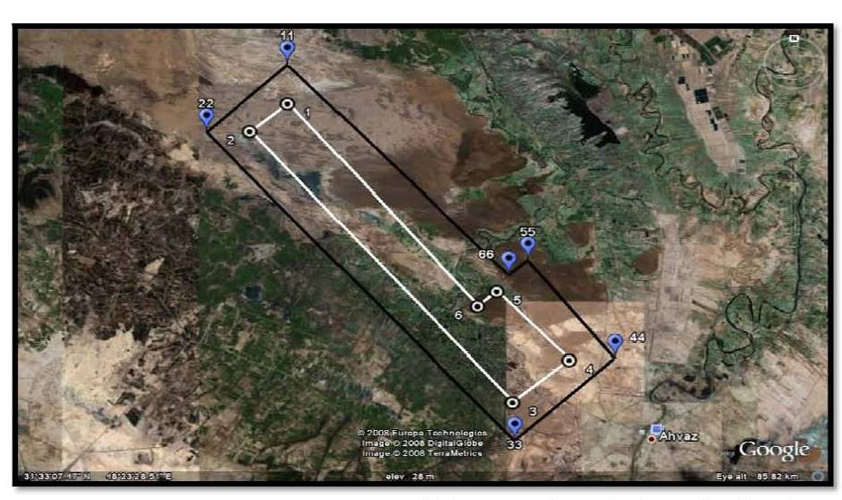
Figure 1: Site Location

WELLS ITEMS IN PRODUCTION FOR FULLY DEVELOPMENTPRODUCTION

Number of Wells
No. of 14 wells with three existing wells (totally 17 wells) will be considered for fully development production (Phase-1).
The total number of production wells for the design base is 17 for initial field life which is from Ilam & Sarvak Production wells.

Well location:
Below table shown the location of wells:
No.14 wells is considered for phase-1 which is collected to three available wells and will be send to band-E-Karkheh production plant
One water disposal well has been nominally located away from the Central Process Facility for conducting water from separation area to disposal well.

Well Flow rates
The BKH production wells are expected to be completed according to above items and operate at max. Operating Production rate (Max: 30000 STB/Day @ outlet of plant which is delivered to boosting station) .water cuts is considered for inlet fluid facility 50. The maximum production design oil and water flow rate at inlet of PU depend on reverse and back calculation by software for reaching to aim flow rate
The Target flow rate is considered for phase-1(fully development) is 30000 oil Stb/Day which is reserved in storage tank & transferred to boosting station.
The planned guide capacity (PGC) shall be considered Min. 1.1~1.2 times planned guide rate (PGR). [PGC= PGR x (1.1~1.2)]
Therefore equipment sizing should be submitted base on below consideration:
Table 5: Well Flow Rates
Well no. | Max. Flow Rate (STB/Day)
BKH-01~17 (Each Well) | 2500
Oil Production (Stb/Day) | 30000
Oil Feed Flow Rate (Stb/Day) | 32500
Total Water Flow Rate(Stb/Day): | 30000
Total considered oil & water flow rate (Stb/Day) | 62500
PGR=1.2 X PGC | 75000

Production Profiles
Method of production and related specification such as artificial device for covering production rate will be finalized by sub-surface section. The CPF will be designed to meet the above capacities & the facilities will be designed on the following production data.
Table 6: Production Data
Item | Design capacity
Oil production rate (STB/D) | 2500 for each well is considered
Water cut (%) | 50
Oil Production Target Capacity (Stb/Day) | 30000
Peak Liquid Production (Stb/day) | 62500 x 1.2
For design purposes, the facilities have been oversized to take into consideration peak production flow rates that could be reached as it has been identified by reservoir simulations for alternative cases.

The test separator design capacity given below is based on typical design capacity for commercially available test separator. The conceptual study sizing basis assumes for maximum production rate from a single well with the same GOR.( SP-100 which is considered in early production phase could be considered as test separator in fully development phase-1).

GENERAL SITE CONDITION

22BTemperature
Maximum recorded air temperature | 54°C
Minimum recorded air temperature | -4 °C
Average Dry bulb temperature | 24 °C
Average Weather Dew Point temperature | 5.7 °C
Maximum temperature for mechanical, civil & structural design | 54°C
Equipment exposed to sunlight | 85°C
Design air temperature for Air coolers | Max.:54°C
Max. Indoor temperature for isolated buildings with low ventilation and no heating source | 42°C
Min. Indoor temperature for isolated buildings with low ventilation and no cooling source | 10 °C

Relative Humidity
Maximum Relative Humidity | 95%
Minimum Relative Humidity | 10%
Maximum Average Relative Humidity | 75%
Minimum Average Relative Humidity | 22%

24BRainfall
Average annual | 200 mm
Maximum Average annual | 460 mm
Design Snow Load | Hold kg/m²
Maximum in one month | 160mm
Design rainfall intensity | 50 mm/h*
*Since rainfall intensity is not available, rate of 50 mm/h is used based on section 5.7.2 of IPS‐E‐CE‐380.

5BBarometric Pressure
Maximum barometric pressure at ground level | 1010 mbar
Average barometric pressure at ground level | 1000 mbar
Minimum barometric pressure at ground level | 990 mbar

26BWind
Maximum wind velocity (km/hr) | 130
Prevailing wind direction | 270°  West and North West
Direction of Max. prevailing speed | 315°
- Mist & Dusty weather is reported at site location. Special provisions are required for dust storms

27BElevations
Site : | Band-E-Karkheh
Altitude above Sea Level (m) | 150
Ground Water Level (m) | approximately 2 meters

28BSeismic Loads
Zone condition | UBC 97 ZONE4
Importance factor | 1.0
Seismic Acceleration (m/s²) | 0.35g

Air Conditioning
Design data for air conditioning are as follows:
Dry bulb temperature in summer | 25±2 °C
Dry bulb temperature in winter | 22±1 °C
Relative humidity | 50±5 %

Soil Condition
Summer Ground Condition | 32 °C
Winter Ground Condition | 10 °C
Soil Thermal Conductivity | - w/m.c

PROCESS DESIGN BASIS

Fluid Data & Fluid Characteristics
Several DSTs have been taken from the BKH-2 well Ilam Reservoir. The BKH key general fluid characteristics are based on the BKH-2.

Table 7: Reservoir Properties
[Summary of Assumed Reservoir Oil Properties (Preliminary data from BKH-2 well)]
PROPERTY | UNIT | VALUE
Initial reservoir pressure | Bara | 441.7
Initial reservoir temperature | °C | 111
Reference depth | m | 3665
Gravity | °API | 24
Gas / Oil ratio (GOR) | SCF/bbl | 250
Bo | Bbl/rb | 1.56
Pbp | Bara | 196
H2S in reservoir fluid | ppm wt | 30
Sulphur | ppm wt | 3.9%
CO2 | mol % | 3.5
Elemental sulphur | mol % | Hold
Wax | Wt % | 5.3
Wax appearance temperature | °C | Note 1
Asphaltenes | Wt % | 11.8
BETX | - | Hold
Note: A wax appearance temperature of 40°C has been assumed and all above data shall be confirmed during detailed design.

For avoiding wax and Asphaltenes in flow line below assumption is considered during basic phase:
- Chemical Injection facility and anti deposit according to chemical consumption list.
- Corrosion allowance : 3.2 mm for flow line and separator
- Requirement of NACE-MR-0175 & ISO-15156-2 for material selection
- Underground flow line

Hydrocarbon Composition:
The composition or design is based on the DST2a and is derived from a review of PVT and composition data from the laboratory analysis performed compositional analysis. This composition is presented below on a dry basis. The compositions used in the simulations will be water saturated and have the requisite volumes of hydrate inhibitor added.
Below table show well (BKH-2) composition which is considered for process surface facilities and shall be finalized during FEED or Detail engineering.

Table 8: Composition of Well fluid
Composition of Well fluid
Component | Mol % (SUMMER & WINTER CASE)
H2O | 0.00
H2S | 0.00
Nitrogen | 0.419874
CO2 | 0.769769
Methane | 17.22483
Ethane | 8.46746
Propane | 7.36779
i-Butane | 1.639508
n-Butane | 4.128761
i-Pentane | 0.979706
n-Pentane | 2.89913
n-Hexane | 5.39838
C7+* | 50.70479

Table 9: Preliminary Fluid Characterization
Preliminary Fluid Characterization
Component | Mol wt | Liq. density [Kg/m³] | Crit. T [C] | Crit. P [Psig] | Accentric factor | Normal Tb [C] | Crit. V [m³/kg mol]
BKH-2-C7+ | 316.09 | 906.67 | 483.9 | 294.7 | 0.6108 | 285.21 | 0.7039

Data in Extrapolated from BKH-2 test report and lumped, could be considered for other wells, all data shall be checked during detail engineering phase.

Dead-oil water emulsion viscosity and live oil viscosity are not currently available. Further studies will be carried out to determine the potential for emulsions and worst condition flow in pipeline of facilities. The design of the CPF will allow for any potential emulsions.

Thermodynamic Model: Peng Robinson

Max. Water cut 50% is considered.
- There is not any PVT reported about existing H2S in Band-E-Karkheh field. But with respect to experience of nearby field (Bangestan group) it is assumed that crude oil will be sour. So in Detail engineering all data especially H2S concentration will be finalized during FEED.

Dead Oil Viscosity Data

Viscosity data of the BKH oil is presented below:
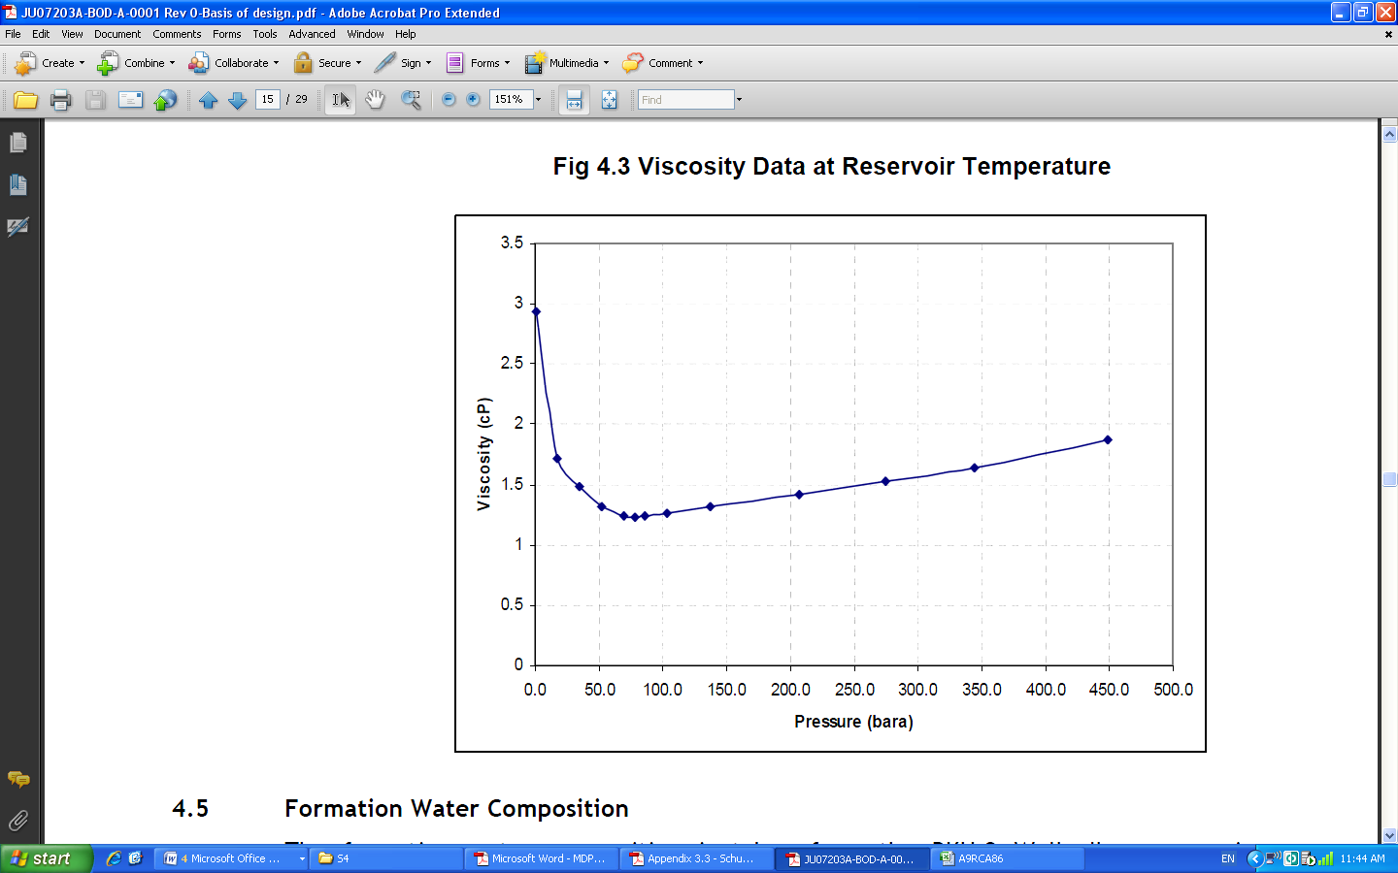
Figure 2: Viscosity Data at Reservoir Temperature

Formation Water Composition from wells

The formation water composition is taken from the BKH-2 Well, Ilam reservoir:
Table 10: Formation Water Composition From well
Reservoir | Ilam
Depth (m)
Specific Gravity @ 15.6/15.6 deg C | 1.14
Total Dissolved Solids, TDS (g/l) | 226-264
pH Value | 4-5.1
Resistivity (Ohm-m) | 0.05
H2S (ppm) | None
Na+ (g/l) | 68-72
Ca++ (g/l) | 8-10
Mg++ (g/l) | 0.9
K+ (g/l) | 2.6-3.2
Sr++++ (g/l) | 0.4-0.46
Total Fe+++ (mg/l) | 170-260
Cl- (g/l) | 121-131
SO4-- (ppm) | 0-0.9
CO3-- (ppm) | None
HCO3- (g/l) | 3.5
Zn (mg/l) | 1-2
Mn (mg/l) | 3
Ba (mg/l) | 0-2

Potable Water Properties:
The major desirable characteristics of potable water shall be based on W.H.O and Iranian water organization standards. The W.H.O. indicative values are given as:

Table 11: Potable Water Properties
Sr. | Parameter | Unit | Specification
1. | PH |  | 6.5-8.5
2. | Turbidity | NTU | < 2
3. | TDS | mg/l | <400
4. | Total Hardness | mg/l as CaCO3 | 80~120
5. | Ca Hardness | mg/l as CaCO3 | 60~80
6. | Mg Hardness | mg/l as CaCO3 | 73‐97
7. | Chlorides | mg/l as Cl‐ | 250
8. | Bicarbonate | mg/l as CaCO3 | 80~120
9. | Chlorine | mg/l as Cl‐ | 0.1
10 | Copper | mg/l | <1

Table 12: The Iranian National Standard No. 1053 for drinking water, issued by Iranian Institution of standard & Industrial Research is presented in following table:
TEST |  | Max. Desired Limit  ( mg / lit )
Total Dissolved Solids | - | 500
Total Hardness | CaCO3 | 150
Permanent Hardness | CaCO3 | -
Total Alkalination | CaCO3 | -
Temporary Alkalination | CaCO3 | 0
Sodium | Na⁺ | -
Calcium | Ca⁺⁺ | 75
Magnesium | Mg⁺⁺ | 50
Sulphate | SO₄⁻⁻ | 200
Chloride | Cl⁻ | 200
Total Iron | - | 0.3
Manganese | Mn⁺⁺ | 0.05
Nitrate | NO3⁻ | 0
Ammonia | NH3 | 0.002
Phosphates | P | 0.1
Fluoride | F⁻ | 0
pH | - | 7 ~ 8.5
Turbidity | - | 5

ARTIFICIAL LIFT METHOD:

For expanding the rate of production artificial lift method could be considered by sub-surface facility study and method will be approved by client. The process data and well head pressure depending on project artificial lifting method.

TURN DOWN RATIO

Production unit and facilities shall be capable to work at "Crude oil transfer pumps” Minimum flow.

FEED AND PRODUCT

Specification of tie in lines, incorporating feed and products, has been summarized based on Phase-1 (fully development stage) production & will be submitted in P&ID’S.

Process conditions and specification at battery limits of this project will be submitted in PFD.

Product Specification depends on process facility application and in early production gas shall be removed from live oil.

SOFTWARE

Aspen‐HYSYS version 7.1 is used for the process simulation and Pipesim software (Version 2008.1) is used for pipeline simulation and hydraulic studies.

UNITS OF MEASUREMENT

SI or METRIC Units may be used for calculation; however, all final results shall be presented in SI units.

All equipment specification, sizes, etc. which are issued for client’s approval shall be in SI units.

Process flow Diagrams and materials balances may be presented in SI Units.

All piping sizes will be in English units.

Temperature | °C (°K)
Pressure | Barg, kpa (psig)
Weight (mass) | Kg (Ib)
Volume (liquids) | m³ (ft³)
Volume(gases) | Nm³ or Sm³ (ft³)
Density | kg/m³
Flow (liquids) | kg/h (Ib/hr)
Water | m³/h (ft³/h)
Hydrocarbon Condensate or Liquid | STBD
Chemical | LPM
Flow (gases) | kg/h (Ib/hr)
Natural gas | MMSCMD (MMSCFD)
Air/Nitrogen | m³/h, Nm³/h or Sm³/hr (ft³/h)
Power | kW
Heat transfer coefficient | W/m2.°C
Heat capacity (Specific Heat) | kJ/kg.°C
Thermal Conductivity | W/m.°C
Viscosity | CP
Length, Diameter | m or mm(In)
Pipe Sizes , | In
Nozzle Sizes | In
Velocity | m/s
Heat Duty | kW
Enthalpy | kJ/kg
Flange Rating | lb
Voltage | V
Current | A
Impedance | Ohm
Capacitance | Farad
Other electrical units | See IEC

STANDARD CONDITION
Pressure: 1.013 Bara
Temperature: 15.6 °C

NUMBERING PROCEDURE
Numbering of equipment, instrumentation equipment, line pipe and technical document must be based on IPS Standard or as per document: “Process Plant Identification and Numbering System”

PROCESS LIFE TIME
All equipments shall be designed for minimum service life of 30 years.

Distribution of Flow
All production wells shall be routed to the inlet manifold which shall be designed for Peak production rate by considering water cut .The base case for production plant is considering three phase separator, oil desalting facilities, oil stabilizer and H₂S removal tower will be designed with a total oil liquids production rate. Gas and liquid transferring line shall be sized based on project requirement and criteria and liquid fluid will be send to boosting station & gas will be send to NGL 3200 by compression stage.
For process facilities, Flow lines, the planned guide capacity (PGC) shall be considered Min. 1.1 times planned guide rate (PGR). [PGC= PGR x (1.1~1.2)]

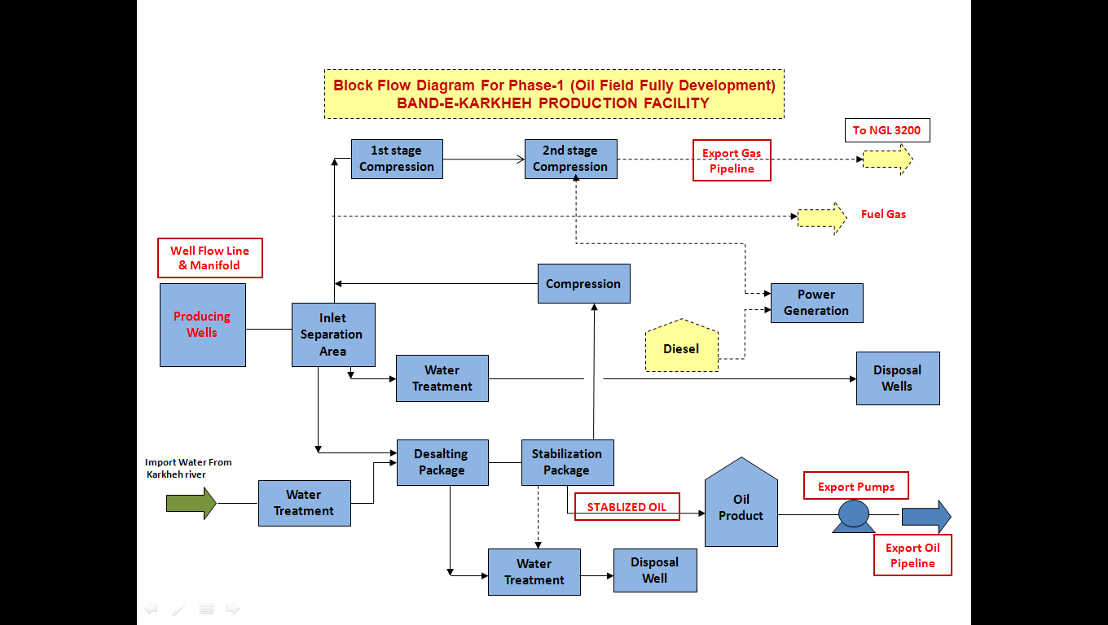
Figure 3: Block Flow Diagram

According to the well field configuration best case flow line study gathered case shall be implemented.

Unit brief identification:
Main Units:
Main unit which is called process unit and will be described as follow:
Unit 10
Including:
- Main Flow Line and Manifold
- Separation Area Including 1st & 2nd Separators & Test Separator
- Crude Desalting Package
- Crude Oil Stabilization Package
- Storage tanks
- Crude Oil Metering Package
- Main Pipeline and Launcher/Receiver Trap
- Hot oil package
- Gas Re-Pressurizing & Transportation Facilities
- Main Pipeline and Launcher/Receiver Trap
- Export Gas Metering Package Including Prover
- Fuel gas supply system
- chemical packages in Process plant
Off site utility facilities including of:
Unit 20
- Instrument air package
- Nitrogen package
Unit 30
- Raw Water / Potable Water supply &Treatment Package
Unit 40
- Produced Water Treatment Package
Unit 50
- Flare & Burn Pit Package
- Drainage System (Open & Close Drain System)

Unit Specification and Limitation:

Overall:
- Plant oil production rate at normal case: 30,000 Stb/day
- Predicted gas flow rate based on GOR at normal case :7.5~8 MMSCFD
- PGR=1.1~1.2 x PGC
- Wells water cut=30%
- Production gathering system & process facilities will be supplied to NACE MR0175/ISO 15156 to cover any eventuality of souring of the reservoir or break through into the sourer Sarvak formation
- Chemical injection facilities are required on the wellhead and a separation area stage (study on type and dosing rate shall be finalized by vendor).

Oil and gas separator device:
For separation gas & water from oil two stage three phase separators is considered .plant stage consisted of stabilizer and storage tank. Separator pressure is considered based on max.oil recovery system and shall be specified in process flow diagram and related study.
Because of available water in entering fluid & high volume water cut it is recommended to consider three phase separator for 1st & 2nd stage .separator stage pressure is mentioned in process flow diagram by considering maximum recovery factor .all data shall be finalized in detail stage.

Oil Treatment in Desalter specification
- Oil is dehydrated and salts removed in a min. 2 stage electrostatic Desalter (Finalized by Vendor).
- Salt in crude: 14 ppm
- BS&W: < 0.025% vol.
- Water supply : From Karkheh River

Oil Stabilization and H2S Removal Package:
- Reid Vapor Pressure (RVP): < 8 Psia
- Residual H2S : < 20 ppm (wt)

- The RVP specification is the primary factor in sizing the stabilizer due to the low H₂S content in the well fluids. However, it is noted that the stabilizer is currently designed to provide performance by considering sum of mole fraction of methane & ethane shall be set to zero in summer and winter case.
- Hot oil is used to provide the required duty for the Reboiler. Further studies on the Asphaltenes will be required to determine maximum temperatures allowable to prevent cooking the Asphaltenes. Operating the stabilizer at a lower pressure could be considered during the detail stage phase. It is to note that experience and normal industry practices indicate that a maximum temperature of 210°C is possible before the Asphaltenes coke up the stabilizer.
- Oil export will take the northern route around Ahvaz to GHARB Boosting station. Delivered pressure is considered to sink is min.150 Psig/max.:500 Psig , 30 psig). The oil will have an RVP & H₂S specification.

LP and HP Gas Compression
- The compressors stages are designed for the peak production rate resulting in a total associated gas rate of 6.5~8 MMSCFD (over design safety factor on flow rate is considered 20%) i.e. a rate of approximately 10 MMSCFD. Each compressor package including of suction scrubber, compressor, after cooler .The Gas Compressor & Driver Selection Study shall be finalized during detail stage.
- The pressure profile has been determined to provide compressor discharge temperatures which are predicted to be below the 150°C threshold that is generally accepted as ensuring reliable compressor operation.
- Compressor ratio shall be considered according to general design practice and IPS standard. Peak flow rate and gas compression power requirements have been established for the LP and HP Compressors based on the ‘Hysys’ process simulation data. A single operating case has been considered for the sizing and selection of the compressors, this being based on the plateau oil production.
- Necessity of H2S removal system or package in production plant shall be finalized by client during detail stage. At this project delivered gas is considered NGL 3200. Delivered pressure is considered to sink is min.650 Psig/max.:700 Psig

Test separator:
- Test separators shall be installed at the CPF to enable testing all the production wells individually.

Produced Water Specification
- Produced water and wastewater shall be re-injected into the Ilam and/or Asmari reservoir for disposal. No. of disposal wells depend on reservoir study and criteria. The oil in water specification for produced water disposal is <40 mg/l. Treatment package and specification shall be accordance to environmental limitation and reservoir specification
- The produced water will be disposed of separately to the wastewater until further tests have been carried out to determine any potential scaling problems.

Tankage Area:
- Oil after stabilizing shall be reserved into storage tank for reservation. At current stage oil will be send to GHARB boosting station via. Pump and related pipeline.
- No. of storage and capacity shall be finalized by client during detail stage.

Chemical Injection package and specification:
Appropriated chemical injection for likely wax, Asphaltenes, scales,…. Is considered based on UFD diagrams and injected to appropriated location. Type, dosing rate, process specification and volume shall be finalized by package supplier.

UTILITY CONDITIONS

Fire Water
Fire water tank with related safety system is considered for fully development phase with below consideration:
Fire water will be supplied from Karkheh River. Raw water flows from well to the fire water tank.
- Supply Pressure, (Barg): 10-10.5
- Design Pressure, (Barg): 12.5
- Design Temperature, (⁰C): 85

Instrument and plant air
A new instrument and utility air system is required. The consumption of the instrument and utility air on Band-E-Karkheh fully development phase is mainly for instrumentation and also pneumatic systems.
Instrument and Plant air will be supplied by air compressor package that shall be considered for this unit.
Compressed air package for this unit including air filter, air compressor (oil free), after cooler, air receiver, air drier package and controls will be supplied with following condition:

Table 13: Potable Water Properties
 | Instrument air | Plant air
Max. Supply temperature,(°C) | 65 | 65
Min pressure;(Barg) | 6 | 6
Normal pressure; (Barg) | 8 | 7.5
Max. pressure;(Barg) | 10 | 10
Max allowable working Temperature, (°C) | 150 | 150
Max allowable working Pressure, (Barg) | 10 | 10

Oil free air shall be provided for both instrument and service system, 15 minutes hold-up for air is provided during electric Power failure.
The Compressed air is required in the complex for following usages:-
- As Instrument Air
- As Plant Air for regeneration and other users.
- As Service Air for hose stations and for other requirements of the complex.
Compressed air required for all of the above uses is generated at a centralized location in the plant and distributed to the various users through headers. There will be a common surge/knock-out drum for both plant and instrument air in the compressed air system.
Ambient air conditions for design of air compressors are as above table (site condition).
The dew point of the instrument air downstream the Air dryers must be -40⁰C at standard conditions.

Nitrogen
Usage is intermittent consumption for purging, blanketing during start-up/shut-down periods or maintenance activities.
Nitrogen will be supplied by bottle or process package depend on process requirement .type of process package or QTY of N₂ bottle shall be studied by EPC contractor.
Below criteria and limitation should be considered for selection and design of package:

Oxygen content | 10 ppmv max.
Carbon dioxide content | 1 ppmv max.
Water content | 1 ppmv max.
Oil content | 0 ppmv max.
Other hydrocarbons | 0 ppmv max.
Temperature normal | Amb.
Design | -4/ 85°C for all parts exposed to solar radiation
Pressure Design | max./nor./min.: 12 Barg/ 9 Barg/ 8 Barg
Max. Allowable pressure drop | 1.3 Bar for whole package

Waste Water System
Required and allowable specification of effluent from waste water treatment system shall be as follows:
- Diameter of solid: below 10 micron
- Oil in water: 10 ppm
- SRB: 10#/mlit
Treated water must be injected to disposal wells which are defined by subsurface facility study.
Injection flow rate considered based on heat and material balance & max. Required well head pressure of water injection to wells shall be finalized in detail stage by EPC contractor.The produced water and wash water are treated and disposed of down disposal wells. It is currently unknown whether the waters are compatible. In order to avoid potential scaling and blocking of the disposal wells as a base case the water will be treated separately and disposed of in different wells.

Potable & Service Water
The raw water flows from Karkheh River to the water treatment package which is installed in production & desalting unit for providing potable water according to W.H.O standard is considered.
Fresh water will be supplied from Karkheh River. Information on the quality of water from the Karkheh River and the amount of treatment required shall be finalized during Detail Stage. The water will be delivered to the CPF using a pumping station located at the river. Preliminary treatment has been provided as part of the detail engineering study and includes a reverse osmosis package, vacuum de-aeration package and Ultra Violet (UV) ozonation package.
Service & plant waters are provided from fresh water tank which is considered in process plant.

Flare System
New LP&HP flare stack will be supplied for this unit & compression unit for emergency flaring of hydrocarbons. Flare system are included flare K.O. drum, flare ignition system and flare stack.

Chemical Package
Chemical considered in this project consist of according to below items:
- Corrosion/Scale Inhibitor Package
- Wax & Asphalting Inhibitor Package
- Demulsifier Package
- DRA Injection Package
Detail of chemical package and dosing rate shall be studied by vendor supplier at detail stage.
- For Desalter package required chemical package shall be finalized by vendor such as oxygen scavenger, biocide, anti-foam, scale inhibitor, h/c soluble

Fuel gas
Fuel Gas will be supplied from separated gas in 1st stage separator (Ilam separator) and other facilities shall be considered.
For backup system fuel gas cylinders with appropriate device shall be considered for flare & burn pit package ignition system and flare purging backup.
QTY and volume of cylinders shall be finalized during detailed design based on vendor data.

Fuel Oil System
Fuel oil is required for providing diesel power generation to emergency and essential equipment when the normal power supply is not available and for diesel fire water pumps.

Closed and Open Drains
A closed drain system will be provided to collect hydrocarbon liquids drains. Any gas purged and relieved sends to flare k.o drums
Oil in off-spec storage tank will be recycled to the process.
Open drains have been provided for maintenance and wash water. These are collected and routed to the water treatment facilities or API separator.

Hot oil package:
The heating medium used is assumed to be hot oil in order to provide the required duty for the in stabilizer Reboiler.
Based on process simulation required hot oil flow rate and duty shall be studied by considering reaching the process specification in tower and oil outlet stream such as RVP & H₂S concentration.
Hot oil package detail shall be finalized by vendor supplier.
For calculating the total required Oil, the following consumptions are considered:
- Boiling point of oil shall be higher than 250°c
- Heat capacity of oil is considered 2.8 Kj/Kg.°C
- The maximum oil rate is depending on required Reboiler duty which is mentioned in process duty spec and H&M.
- About 40% over design factor is used for oil system calculation.
All of these data shall be finalized during detail design phase by EPC Contractor/ Hot oil package Vendor.

Control System
A control system using equipment proven in the international oil industry will be used for the field. This system will be based upon the use of smart field devices for both process control and safety systems, with dedicated controllers/logic solvers for each function, i.e. DCS controller subsystem for Process Control, redundant PLCs for ESD. This will provide commonality of spares across project control and safety devices, enhanced diagnostics for maintenance, and familiarity for maintenance personnel.
The DCS will be housed in a number of field equipment rooms which are connected by both ESD and process control networks to the central control room at the DCS

Power Generation
Required power will be supply by client from power network and it is not required to consider power generation plant which is installed in the process plant.
The power rate will be specified in process load list and finalized by client.
Additionally an emergency diesel generator shall also be provided for emergency condition

Electricity
The following voltage levels shall be selected for the electrical system at rated frequency of 50 Hz. Electrical equipments shall be anyway suitable for operation with voltage variations ranging within ± 5 % of rated values. AC electrical equipment shall be anyway suitable for operation with frequency variations ranging within ± 5 % of rated values.
The applicable voltage levels, frequencies and neutral systems shall be as follows:
- MV power system: 6 kV
- MV distribution system: 6 kV
- Emergency Generation System: 400 V
- Motors up to 150 kW (included): 400 V ,3 ph ,3 wires
- Motors above 150 kW: 6 kV ,3ph ,3 wire
- Motors less than 0,37kW:230 V ,1ph ,2 wires
- Instruments (critical supply from ups): 230 ,50 HZ
- Lighting system and outlets: 230\400 V,50 HZ
- Safety lights in MV substation: 110 VDC (+10%, -15%)
- Safety lights in other areas: 230\400 V ,50 HZ, 3/5 wires
- Communication system: 230 V 1ph, 50 HZ
- Electrical control and protections of MV switchgears: 110 VDC (+10%, -15%)
- Electrical control of 400 V motor starters: 230V ,50 HZ

ENVIRONMENTAL ASPECTS

Environmental Noise Limit
Environmental noise limits are generally different depending on the time of day. The more stringent of the two different time periods shall be the basis of the design since the operating mode of the plant does not change between the day and night.
Table 14: Noise limits summary
Total Noise limit -Leq
Category of zoning | Daytime(dBA) (7am-10pm) | Night Time(dBA) (10pm-7am)
Residential | 55 | 45
Industrial | 80 | 80

The limits taken as reference for this project are those underlined in the table above. Consequently as an alternative, the noise level at the plant fence shall not exceed 75 dBA.

Emission to air limitations
Based on Iranian Petroleum Standard (Engineering Standard for Air Pollution Control), for emission limits the following figures can be considered:
Table 15: Emission to air limitations
Pollutant
H2S | 10 mg/m3 | 6.62 ppm
Carbon monoxide 150 ppm | 0.1 (vol %) | 150 ppm
Sulfur oxide | 0.2 (vol %) | 800 ppm
Particles | 50 (mg/m3) | -
Hydrocarbons | 20% opacity | -
Photochemical | 30 mg/m3 | -
Non photochemical | 300 mg/m3 | -
Nitrogen Oxides | - | 210 ppm

